Hardware design Specification

for SafeSpace2.0

Content Page

1 Scope 7

2 Referenced documents 7

3 Abbreviations 8

4 Applied Standards 9

5 Description of Hardware in SafeSpace2.0 10

5.1 Functions 10

5.1.1 Safety Controller 10

5.1.1.1 HF101: Clock and MCU 10

5.1.1.2 HF102: Watchdog function 10

5.1.1.3 HF103: Power supply function 10

5.1.1.4 HF104: Encoder function 10

5.1.1.5 HF105: Current sensor function 10

5.1.1.6 HF106: Safety input function 10

5.1.1.7 HF107: Safety output function 10

5.1.1.8 HF108: STO function 11

5.1.1.9 HF109: Temperature function 11

5.1.1.10 HF110: EMIF function 11

5.1.1.11 HF111: Brake control function 11

5.1.1.12 HF112: EtherCAT function 11

5.1.1.13 HF113: AMP board interface function 11

5.1.1.14 HF114: Power control board interface function 11

5.1.1.15 HF115: Safety Communication board interface function 11

5.1.2 Power Control Board 12

5.1.2.1 HF201: AC to DC Rectifier function 12

5.1.2.2 HF202: PN Voltage discharge function 12

5.1.2.3 HF203: PN Overvoltgae detection function 12

5.1.2.4 HF204: PN Undervoltgae detection function 12

5.1.2.5 HF205: Regenerative discharge control function 12

5.1.2.6 HF206: Regenerative discharge resistance overheating detection function 12

5.1.2.7 HF207: Regenerative discharge resistance open circuit detection function 12

5.1.2.8 HF208 Pre-Charge Function 12

5.1.2.9 HF209 Blackout detection Function 12

5.1.3 AMP Board 13

5.1.4 Safety Communication Board 14

5.2 System block diagram 15

5.3 Hardware block diagram 16

5.3.1 Safety Controller 16

5.3.1.1 External Interface 17

5.3.1.2 Internal Interface 18

5.3.2 Power Control Board 22

5.3.2.1 External Interface 23

5.3.2.2 Internal Interface 24

5.3.3 AMP Board 26

5.3.3.1 System Interfaces 26

5.3.4 Safety Communication Board 29

5.3.4.1 External Interface 29

5.3.4.2 Internal Interface 30

6 Detailed design 31

6.1 Safety Controller 31

6.1.1 Clock and MCU(: HF101) 31

6.1.1.1 Design Requirements 31

6.1.1.2 Functional Description 31

6.1.1.3 Specification 31

6.1.2 Watchdog function(: HF102) 33

6.1.2.1 Design Requirements 33

6.1.2.2 Functional Description 33

6.1.2.3 Specification 34

6.1.3 Power supply function(: HF103) 35

6.1.3.1 Design Requirements and functional description 35

6.1.3.2 Required power 35

6.1.3.3 Voltage Monitoring 37

6.1.4 Encoder function(: HF104) 39

6.1.4.1 Design Requirements 39

6.1.4.2 Functional Description 39

6.1.4.3 Specification 39

6.1.5 Current sensor function(: HF105) 41

6.1.5.1 Design Requirements 41

6.1.5.2 Functional Description 41

6.1.5.3 Specification 42

6.1.6 Safety input function(: HF106) 44

6.1.6.1 Design Requirements 44

6.1.6.2 Functional Description 44

6.1.6.3 Specification 45

6.1.7 Safety output function(: HF107) 47

6.1.7.1 Design Requirements 47

6.1.7.2 Functional Description 47

6.1.7.3 Specification 48

6.1.8 STO function(: HF108) 49

6.1.8.1 Design Requirements 49

6.1.8.2 Functional Description 49

6.1.9 Temperature function(: HF109) 50

6.1.9.1 Design Requirements 50

6.1.9.2 Functional Description 50

6.1.9.3 Specification 50

6.1.10 EMIF function(: HF110) 52

6.1.10.1 Design Requirements 52

6.1.10.2 Functional Description 52

6.1.10.3 Specification 52

6.1.11 Brake control function(:HF111) 54

6.1.11.1 Design Requirements 54

6.1.11.2 Functional Description 54

6.1.11.3 Specification 54

6.1.12 EtherCAT function(:HF112) 56

6.1.12.1 Design Requirements 56

6.1.12.2 Functional Description 56

6.1.12.3 Specification 56

6.1.13 AMP board interface function(:HF113) 57

6.1.13.1 Design Requirements 57

6.1.13.2 Functional Description 57

6.1.13.3 Specification 57

6.1.14 Power control board interface function(: HF114) 58

6.1.14.1 Design Requirements 58

6.1.14.2 Functional Description 58

6.1.14.3 Specification 58

6.1.15 Safety communication board interface function(: HF115) 59

6.1.15.1 Design Requirements 59

6.1.15.2 Functional Description 59

6.1.15.3 Specification 59

6.2 Power Control Board 61

6.2.1.1 HF201: AC to DC Rectifier function 61

6.2.1.2 HF202: PN Voltage discharge function 61

6.2.1.3 HF203: PN Overvoltage detection function 62

6.2.1.4 HF204: PN Undervoltgae detection function 63

6.2.1.5 HF205: Regenerative discharge control function 64

6.2.1.6 HF206: Regenerative discharge resistance overheating detection function 65

6.2.1.7 HF207: Regenerative discharge resistance open circuit detection function 66

6.2.1.8 HF208 Pre-Charge Function 66

6.2.1.9 HF209 Blackout detection Function 67

6.3 AMP Board 68

6.3.1 설계 배경 68

6.3.1.1 로봇을 위한 모터타입 선정 68

6.3.1.2 전력변환 토폴로지 68

6.3.1.3 IPM (Intelligent Power Module) for Inverter of AMP Board 68

6.3.1.4 IPM 선정 68

6.3.1.5 전류센서 선정 및 전류파라미터 허용치 검토 69

6.3.1.6 AMP설계 반영될 규정항목 69

6.3.2 절연 (HF301) 69

6.3.2.1 고려사항 요약 70

6.3.2.2 과도전압 범주 설정 70

6.3.2.3 공간거리 및 연면거리 71

6.3.2.4 PCB 아트웍 고려사항 73

6.3.2.5 PCB 제작물 사양 74

6.3.2.6 외함접지와 고전압라인 용량성 커플링 절연 74

6.3.3 IPM 구동부 (HF302) 75

6.3.3.1 고려사항 요약 75

6.3.3.2 PWM 전달 사양 75

6.3.3.3 스위칭 전기적 사양 76

6.3.3.4 부트스트랩 커패시터 76

6.3.3.5 Sense 저항 또는 Shunt 저항 77

6.3.3.6 IPM 제어용 전원부 77

6.3.4 IPM Fault 신호 출력부 (HF304) 79

6.3.4.1 고려사항 요약 79

6.3.4.2 폴트 출력회로 구성 80

6.3.4.3 과온도 80

6.3.4.4 암쇼트 81

6.3.4.5 제어전원 모니터링 81

6.3.4.6 부트스트랩 상단 충전전압 모니터링 81

6.3.5 전류 센싱부 (HF304) 81

6.3.5.1 고려사항 요약 82

6.3.5.2 전류센서 타입 선정 82

6.3.5.3 IPM 용량별 전류센서 매칭 82

6.3.5.4 W상 전류센서 83

6.3.6 방열 (HF305) 83

6.3.6.1 고려사항 요약 83

6.3.6.2 IPM 열저항 및 방열구조 84

6.3.6.3 열전달 매개체 (써멀구리스, 써멀패드 등) 84

6.3.6.4 방열판 치부 84

6.4 Safety Communication Board 86

6.4.1 Safety-Communication Function (: HF401) 86

6.4.1.1 Design Requirements 86

6.4.1.2 Functional Description 86

6.4.2 Power supply function (: HF402) 87

6.4.2.1 Design Requirements and functional description 87

6.4.2.2 Required power 87

7 Electronic/Electric components 89

7.1 Parts list 89

8 Revision History 90

# Scope

SafeSpace2.0 is a robot safety system for Hyundai robot. The document contains the hardware design specification of SafeSpace2.0.

SafeSpace2.0 consists of the safety controller (H/W, S/W), encoders, current sensors, parameterization tool and safety relays. SafeSpace2.0 supervises the movement of robot controlled by a non-safety main controller.

This specification shall meet the SRS(Safety Requirement Specification).

# Referenced documents

| Document Name | Document Number |
| --- | --- |
| Safety Requirement Specification for SafeSpace | I170H14-A10-16-001 |
| Safety Concept & SRS the Robot for Collaborative Applications V1.2 | I1N0-SR19-0101 |
| C2000™ Software Diagnostic Library for TMS320F2838x  API USER’S GUIDE |  |
| C2000™ CPU Memory Built-In Self-Test | SPRACB9–November 2017 |
| C2000™ Hardware Built-In Self-Test | SPRACA7–October 2017 |
| TMS320F2838x Flash API | SPNU632–December 2019 |
| TMS320F2838x Real-Time Microcontrollers With Connectivity Manager  Technical Reference Manual(TRM) | SPRUII0C–MAY2019–REVISED FEBRUARY 2021 |
| Digital Motor control software Library(SMOPOS, Permanent Magnet Synchronous Motor Angular Position Estimation Based on Sliding Mode Observer) | SPRU485A-August 2001 |

# Abbreviations

The following abbreviations and expression are going to be used within the project.

| Term | Description |
| --- | --- |
| H/W | Hardware |
| S/W | Software |
| T/P | Teaching pendant |
| SIL | Safety Integrity Level |
| PFH | Average frequency of a dangerous failure per hour |
| HFT | Hardware Fault Tolerance |
| STO | Safe Torque Off |
| EMC | Electro Magnetic Compatibility |
| SFF | Safe Failure Fraction |
| DC | Diagnostic Coverage |
| DCavg | Average Diagnostic Coverage |
| MTTFd | Mean Time To Dangerous Failure |
| CCF | Common Cause Failure |
| minHi6COM | Computer Module in Hi6 Robot Control Platform |
| SBC | Safe Brake Control |
| SS1 | Safe Stop 1 |
| SS2 | Safe Stop 2 |
| SOS | Safe Operating Stop |
| SLP | Safely-Limited Position |
| SLS | Safely-Limited Speed |
| SLT | Safely-Limited Torque |
| FSoE | Fail safe over EtherCAT |
| OV | Over Voltage |
| UV | Under Voltage |
| OC | Over Current |
| ES | Emergency Switch |
| SG | Safety Guard |
| SCI | Serial Communication Interface |
| FSI | Fast Serial Interface |
| CAN | Controller Area Network |
| GPIO | General Purpose Input Output |
| EMIF | External Memory Interface |
| FPGA | Field Programmable Gate Array |
| IPM | Intelligent Power Module |
| DC-Link | Direct Current Link : It refers to the voltage at both ends converted from AC(Alternating Current) to DC(direct current) |
| SMPS | Switching Mode Power Supply |
| HC | Hardware Component |

# Applied Standards

| Standard | |
| --- | --- |
| EN ISO 10218-1:2011 | Robots and robotic devices -Safety requirements for industrial robots - Part 1: Robots |
| EN ISO 10218-2:2011 | Robots and robotic devices -Safety requirements for industrial robots - Part 2: Robot systems and integration |
| ISO/DIS 10218-1:2021(E) | Robots and robotic devices -Safety requirements for industrial robots - Part 1: Robots |
| ISO/TS 15066:2016 | Robots and robotic devices — Safety requirements — Industrial collaborative workspace |
| IEC 61508-1:2010 | Functional safety of electrical/electronic/programmable electronic safety-related systems - Part 1: General requirements |
| IEC 61508-2:2010 | Functional safety of electrical/electronic/programmable electronic safety-related systems - Part 2: Requirements for electrical/electronic/programmable electronic safety-related systems |
| IEC 61508-3:2010 | Functional safety of electrical/electronic/programmable electronic safety-related systems - Part 3: Software requirements |
| IEC 61508-4:2010 | Functional safety of electrical/electronic/programmable electronic safety-related systems - Part 4: Definitions and abbreviations |
| IEC 61508-5:2010 | Functional safety of electrical/electronic/programmable electronic safety-related systems - Part 5: Examples of methods for the determination of safety integrity levels |
| IEC 61508-6:2010 | Functional safety of electrical/electronic/programmable electronic safety-related systems - Part 6: Guidelines on the application of IEC 61508-2 and IEC 61508-3 |
| IEC 61508-7:2010 | Functional safety of electrical/electronic/programmable electronic safety-related systems - Part 7: Overview of techniques and measures |
| IEC 61800-5-1:2022 PRV | Adjustable speed electrical power drive systems - Part 5-1: Safety requirements - Electrical, thermal and energy |
| IEC 61800-5-2:2016 | Adjustable speed electrical power drive systems - Part 2: General requirements - Rating specifications for low voltage adjustable speed a.c. power drive systems |
| ISO 13849-1:2015 | Safety of machinery - Safety-related parts of control systems - Part 1: General principles for design |
| ISO 13849-2:2012 | Safety of machinery - Safety-related parts of control systems - Part 2: Validation |
| IEC 62061:2021 | Safety of machinery. Functional safety of safety-related electrical, electronic and programmable electronic control systems |
| IEC 61784-3:2016 | Industrial communication networks - Profiles - Part 3: Functional safety fieldbuses - General rules and profile definitions |
| IEC 61800-3:2017 | Adjustable speed electrical power drive systems - Part 3: EMC requirements and specific test methods |
| IEC 61000-6-7:2014 | Electromagnetic compatibility (EMC) - Part 6-7: Generic standards - Immunity requirements for equipment intended to perform functions in a safety-related system (functional safety) in industrial locations |
| IEC 61326-3-1:2017 | Electrical equipment for measurement, control and laboratory use. EMC requirements. Part 3-1: Immunity requirements for safety-related systems and for equipment intended to perform safety-related functions (functional safety) - General industrial applications |
| SN 29500-1 (SIEMENS NORM) | Expected values, general. |

# Description of Hardware in SafeSpace2.0

## Functions

### Safety Controller

This module shall have the following hardware functions and all safety related parts shall be PL d(SIL 2), Cat. 3., exceptionally safety input(: type1), safety output(: type1) & STO function is PL e(SIL 3), Cat. 4.

#### HF101: Clock and MCU

* + - These MCUs are interconnected through FSI, SCI and CAN interface for cross-checking. This ensure that the calculation results of the two MCUs are compared and verified.
    - Clocks for MCU operation shall be independent components.

#### HF102: Watchdog function

* + - It monitors whether the MCU is operating at a set speed and procedure. In the event of an abnormal situation, the external independent watchdog function activates MCU STO, making the robot system in safe-state.

#### HF103: Power supply function

* + - Power input and generated power shall be protected and monitored.
    - DC24V powers are supplied to two channel circuits and make generates control powers such at 3.3V, 1.2V by each channel’s regulator.
    - These all powers(DC24V, 3.3V, 1.2V and etc) are monitored by MCU via ADC. Also these monitoring values are checked by other channel MCU.

#### HF104: Encoder function

* + - The positions of a robot manipulator are transfered to serial data by encoders in each axis. This serial data are transmitted to the robot controller via RS485 line.
    - This function of SafeSpace2.0 captures these data in middle and inputs to the ZYNQ for serial to parallel data transformation.

#### HF105: Current sensor function

* + - For the robot manipulator, it controls the motor in each axis. For motor control, the each phase current of motor must be feedback.
    - The data of the current sensor is an analog signal and is converted into a digital signal through the ADC of the MCU.
    - For current sensor diagnosis, u-phase and v-phase currents are input to MCU1, and v-phase and w-phase currents are input to MCU2 and cross-checked to diagnose.

#### HF106: Safety input function

* + - The dual output of the other device are input to each MCU. The input circuits are tested and checked by the MCU.
    - The safety inputs are isolated by by photo-coupler or photo-MOSFET.

#### HF107: Safety output function

* + - The safety output circuit include in output monitoring, test line output and feedback input.
    - The safety outputs are isolated by photo-coupler or photo-MOSFET.

#### HF108: STO function

* + - If a safety related function is fail or a hazard situation in robot operations occurs, powers supplied in robot actuators shall be off.
    - For internal STO, output states of each channel’s gate are monitored that gate is normally operated. For external STO, results of STO are monitored using test pulse signal.

#### HF109: Temperature function

* + - The temperature sensors are used to monitoring temperature in module. If over-heated, all functions are shut down and STO signal is outputted to the robot controller by MCU.

#### HF110: EMIF function

* + - The interface between MCU1 and ZYNQ is external memory interface (: EMIF). Also, the interface between MCU1 and SDRAM is EMIF.

#### HF111: Brake control function

* + - Brake release is operated using the digital output of MCU1, and monitoring is confirmed using the digital input of MCU2.

#### HF112: EtherCAT function

* + - MCU1 and ZYNQ (FPGA) of the safety controller communicate with the main controller through EtherCAT communication.

#### HF113: AMP board interface function

* + - The interface data between the safety controller and AMP board are the PWM gating signal, the IPM fault signal and the current sensor feedback signal.

#### HF114: Power control board interface function

* + - The interface data between safety controller and power control board are DC-Link voltage monitoring signal, pre-charge control signal and monitoring signal.

#### HF115: Safety Communication board interface function

* + - The interface between safety controller and safety communication board is implemented by RS485 communication.

### Power Control Board

#### HF201: AC to DC Rectifier function

* + - AC220V 3-phase power is applied and converted to 311 V DC voltage to supply the motor driven main power.

#### HF202: PN Voltage discharge function

* + - This is a function that discharges the PN voltage through a relay when the servo is off, and if the fast discharge is not performed while being charged in the capacitor of the high voltage, the operator may have a risk of electric shock.

#### HF203: PN Overvoltage detection function

* + - It is a function of detecting a state in which a DC voltage for driving an inverter exceeds a set value, and sets a detection voltage designed with a variable resistance. It is detected when the regenerative discharge function fails or an overvoltage exceeding the discharge performance occurs.

#### HF204: PN Undervoltage detection function

* + - It is a function of detecting a state in which a DC voltage for driving an inverter is lowered below a set value, and a detection voltage designed with a variable resistance is set.

#### HF205: Regenerative discharge control function

* + - It protects the power device by discharging the DC voltage through the resistor when the DC voltage rises due to the power generated from the motor, and the discharge start voltage and the discharge end voltage are set with the variable resistance.

#### HF206: Regenerative discharge resistance overheating detection function

* + - Operation detection function of the superheated temperature sensor attached to the regenerative discharge resistance

#### HF207: Regenerative discharge resistance open circuit detection function

* + - Open circuit detection of regenerative discharge resistance

#### HF208 Pre-Charge Function

* + - In order to reduce the in-rush current of the capacitor to charge the PN voltage, the pre-charge relay is driven by motor on/off sequence control and the result is feedback to BD642A.

#### HF209 Blackout detection Function

* + - When a power failure of the AC input power source is detected, the buffer maintains a voltage of DC12V or higher for 1 second, and the main module (H6COM-T) backs up during this predetermined time.

※ The driving voltage specification of the H6COMT is 12 to 24V, and the data backup requirement is 1 second.

### AMP Board

HF.301 : 절연

* 과도전압 범주 설정
* 내전압 사양 대비 연면거리 및 공간거리 최소 요구사항
* PCB 아트웍 고려사항
* PCB 제작물 사양
* 외함접지와 고전압라인 용량성 커플링 절연

HF.302 : IPM 구동부

* PWM 전달사양
* 스위칭 전기적 사양
* 부트스트랩 커패시터
* Sense 저항 또는 Shunt 저항
* IPM 제어용 전원부

HF.303 : IPM Fault 신호 출력부

* 과온도
* 암쇼트
* 제어전원 모니터링
* 부트스트랩 상단 충전전압 모니터링

HF.304 : 전류 센싱부

* 전류센서 타입 선정
* IPM 용량별 전류센서 매칭
* W상 전류센서

HF.305 : 방열

* IPM 열저항 및 방열구조
* 열전달 매개체 (써멀구리스 및 써멀패드)
* 방열판 치부

### Safety Communication Board

This module shall have the following hardware functions and safety communication will be performed.

HF401 : Safety-Communication Function

* + - This MCU perform safety communication function. It will transmit and receive safety data from other safety device.
    - It perform profi-safe function through profinet protocol
    - It can be black-channel.

HF402 : Power supply function

* + - Power source is generated from safe space 2.0. so It could be check by safe space 2.0

Power source will be protected OC protection function.

## System block diagram

The system block diagram is shown in the figure below. For details, refer to SRS.



## Hardware block diagram

### Safety Controller

In the drawing,  represents an function block.



| **No.** | **Components** | **Roles** | **Function** |
| --- | --- | --- | --- |
| C100 | MCU1(Ch.1) | Provide clock source to MCU | SIM1 |
| C200 | MCU2(Ch.2) |
| C101 | Oscillator(Ch.1) | Perform safety functions | SIM2 |
| C201 | Oscillator(Ch.2) |
| C102 | Temperature sensor(Ch.1) | Check temperature around the PCB | SIM9 |
| C202 | Temperature sensor(Ch.2) |
| C103 | Brake Output(Ch.1) | Safe Brake control. | SF18 |
| C203 | Brake Feedback(Ch.2) |
| C104 | OP AMP(IU,IV) | Detected the current sensor. | SIM4, SIM5 |
| C204 | OP AMP(IV,IW) |
| C105 | Protection elements(Ch.1) | Protects under voltage(UV), overvoltage(OV), over-  current(OC) in DC24V power source | SIM3 |
| C205 | Protection elements(Ch.2) |
| C106 | Power regulator &  watchdog1(Ch.1) | Generate and monitor control powers.  Supervise the watchdog pulses. | SIM2, SIM3 |
| C206 | Power regulator &  watchdog1(Ch.2) |
| C107 | OC protection(Ch.1) | Protects overcurrent(OC) in DC24V power source | SIM3 |
| C207 | OC protection(Ch.2) |
| C108 | Buffer, photo coupler &  MOSFET(Ch.1) | Output reserved STO and input feedback, ES, SG with  optical isolation | SIM6, SIM7, SIM8 |
| C208 | Buffer, photo coupler &  MOSFET(Ch.2) |

#### External Interface

In the drawing, represents an external interface.



| **No.** | **Description** | **Items** | **Contents** |
| --- | --- | --- | --- |
| EIF100  EIF200 | Hardwired signal interfaces – external safety related devices(e.g. STO, ES) | Type of data | Discrete signals |
| Exchanged data | State information between MCUs and an external device |
| Data Range | 0 ~ 24V ± 15% |
| Refresh time of data | Less than 5msec |
| EIF300 | EtherCAT communication interfaces (: black channel) – receiving motion control data, monitoring module states and configuration data. | Type of data | Ethernet signals |
| Exchanged data | Motion data(Command/Encoder), configuration data |
| Data Range | EtherCAT protocol(with FSoE) |
| Refresh time of data | Less than 5msec |
| EIF101 | EtherCAT communication interfaces (: black channel) – transmitting motion control data, monitoring module states and configuration data. | Type of data | Ethernet signals |
| Exchanged data | Motion data(Command/Encoder), configuration data |
| Data Range | EtherCAT protocol(with FSoE) |
| Refresh time of data | Less than 5msec |
| EIF102 | Power inputs – supplying DC24V for safety related parts and general purpose parts. | Type of data | Hardwiring(analog) |
| Exchanged data | Power |
| Data Range | 0 ~ 24V ± 15% |
| Refresh time of data | N/A(constant value) |
| EIF103 | Power inputs – supplying DC24V for motor brake parts. | Type of data | Hardwiring(analog) |
| Exchanged data | Power |
| Data Range | 0 ~ 24V ± 15% |
| Refresh time of data | N/A(constant value) |
| EIF104 | RS485 communication interface – connecting to PROFINET board. | Type of data | Differential transmission signal. |
| Exchanged data | State information between MCUs and PROFINET board. |
| Data Range | 8bits |
| Refresh time of data | Less than 10msec |
| EIF105 | Connecting to AMP board.  Current sensors – the values detected motor currents.  The PWM signal used for motor control is output ports. Also, the Servo-On signal used in the motor control sequence is output ports. The IPM fault signal is input ports. | Type of data | Analog signals |
| Discrete signals |
| Exchanged data | Motor current values |
| PWM output, Servo On output, IPM fault input. |
| Data Range | -10 ~ +10V ± 10% |
| 0 ~ 15V ± 15% |
| Refresh time of data | Less than 200usec |
| EIF106 | Connecting to the motor brake. This is the brake control signal. The corresponding signal is composed of brake on/off signal and monitoring signal. | Type of data | Discrete signals |
| Exchanged data | Brake release / hold |
| Data Range | 0 ~ 24V ± 15% |
| Refresh time of data | Less than 200usec |
| EIF107 | RS485 communication interfaces – connecting to motor encoder sensor. It transmits & receives data from the encoder sensor. | Type of data | Differential transmission signal. |
| Exchanged data | position data |
| Data Range | 8-bits |
| Refresh time of data | Less than 200usec |

#### Internal Interface

In the drawing, represents an external interface.



| **No.** | **Description** | **Items** | **Contents** |
| --- | --- | --- | --- |
| IIF100  IIF200 | FSI communication – cross check data between the CPU1s. | Type of data | Discrete signals |
| Exchanged data | Cross check data |
| Data Range | 0 ~ 3.3V ± 10% |
| Refresh time of data | Less than 10msec |
| IIF101  IIF201 | SCI communication – cross check data between the CPU2s. | Type of data | Discrete signals |
| Exchanged data | Cross check data |
| Data Range | 0 ~ 3.3V ± 10% |
| Refresh time of data | Less than 10msec |
| IIF102  IIF202 | CAN communication – cross check data between the CMs. | Type of data | Discrete signals |
| Exchanged data | Cross check data |
| Data Range | 0 ~ 3.3V ± 10% |
| Refresh time of data | Less than 10msec |
| IIF103  IIF203 | GPIO interfaces – cross sync check signal between the MCUs. | Type of data | Discrete signals |
| Exchanged data | Cross check signal |
| Data Range | 0 ~ 3.3V ± 10% |
| Refresh time of data | Less than 10msec |
| IIF104  IIF204 | EMIF – motion data, encoder data, motor current data, configuration data and states data(: IIF104 only).  Sync signal – sync check signal. | Type of data | Discrete signals |
| Exchanged data | Cross check signal |
| Data Range | 0 ~ 3.3V ± 10% |
| Refresh time of data | Less than 200usec |
| IIF105  IIF205 | Supplying clocks pulses to operate MCUs. | Type of data | Clock pulses |
| Exchanged data | Square pulse |
| Data Range | 0 ~ 3.3V ± 10% |
| Refresh time of data | 25MHz |
| IIF106  IIF206 | Sensor values detected ambient temperature. | Type of data | Analog signal |
| Exchanged data | Temperature values |
| Data Range | 0 ~ 3.0V ± 10% |
| Refresh time of data | Less than 10msec |
| IIF107  IIF207 | Watchdog2 signal – To supervise the normal operating of the MCU, it feeds watchdog pulse to supervisor chip (TI TPS3820-33Q1). | Type of data | Discrete pulse |
| Exchanged data | Watchdog pulses |
| Data Range | 0 ~ 3.3V ± 10% |
| Refresh time of data | Less than 200msec |
| IIF108  IIF208 | Watchdog1 signal – To supervise the normal operating of the MCU, it feeds watchdog pulse to supervisor chip (Analog Device LT3641EUFD). | Type of data | Discrete pulse |
| Exchanged data | Watchdog pulses |
| Data Range | 0 ~ 3.3V ± 10% |
| Refresh time of data | Less than 200msec |
| IIF109  IIF209 | Discrete IO signals for STO, Safety Remote IO Interface. These include signals of STO output / monitoring, feedback inputs, test pulses, general purpose input/outputs. | Type of data | Discrete signals |
| Exchanged data | Emergency stop (STO), general purpose data |
| Data Range | 0 ~ 3.3V ± 10% |
| Refresh time of data | Continuously |
| IIF110  IIF210 | Current sensors values detected motor currents.  IIF110 is detected u-phase & v-phase currents, IIF210 is detected v-phase & w-phase currents. | Type of data | Analog signal |
| Exchanged data | Motor currents values |
| Data Range | 0 ~ 3.0V ± 10% |
| Refresh time of data | Less than 200usec |
| IIF111  IIF211 | This is the brake control signal. The corresponding signal is composed of brake on/off signal and monitoring signal. | Type of data | Discrete signals |
| Exchanged data | Brake ON/OFF and feedback signal |
| Data Range | 0 ~ 3.3V ± 10% |
| Refresh time of data | Continuously |
| IIF212 | RS485 communication interfaces – connecting to PROFINET board. | Type of data | Serial communication signals. |
| Exchanged data | State information between MCUs and PROFINET board. |
| Data Range | 0 ~ 3.3V ± 10% |
| Refresh time of data | Less than 10msec |
| IIF300 | EtherCAT communication interfaces – receiving motion control data, monitoring module states and configuration data. | Type of data | Ethernet signals |
| Exchanged data | Motion data(command/encoder), configuration data. |
| Data Range | EtherCAT Protocol |
| Refresh time of data | Less than 5msec |
| IIF301 | RS485 communication interfaces – It transmits & receives data from the encoder sensor. | Type of data | Serial communication signals. |
| Exchanged data | Absolute position data |
| Data Range | N/A |
| Refresh time of data | Less than 200usec |
| IIF302 | The PWM signal used for motor control is output ports. Also, the Servo-On signal used in the motor control sequence is output ports. The IPM fault signal is input ports. | Type of data | Discrete signals |
| Exchanged data | PWM output, Servo On output, IPM fault input. |
| Data Range | 0 ~ 3.3V ± 10% |
| Refresh time of data | Less than 200usec |

### Power Control Board

In the drawing,  represents an function block.

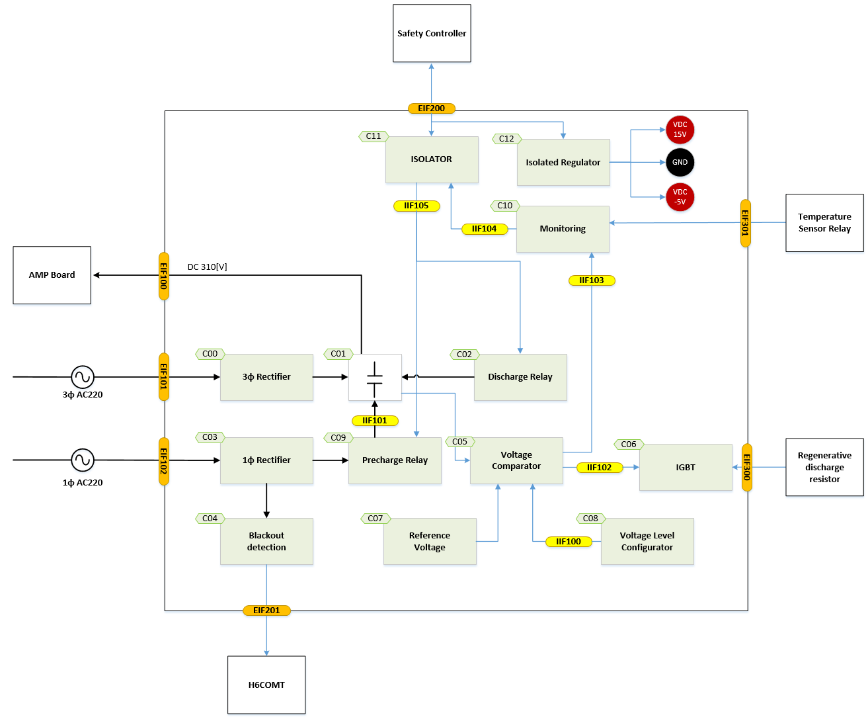

| **No.** | **Components** | **Roles** | **Function** |
| --- | --- | --- | --- |
| C00 | 3ɸ Rectifier | Rectifier Diode Module | HF201 |
| C01 | PN Capacitor Bank | Electrolytic Capacitor Bank |  |
| C02 | Discharge Relay | PN voltage discharge Relay | HF202 |
| C03 | 1ɸ Rectifier | Rectifier Diode Module |  |
| C04 | Blackout detection | Blackout signal detect | HF209 |
| C05 | Voltage Comparator | Voltage comparator (high voltage, low voltage monitoring, IGBT operation control) | HF205 |
| C06 | IGBT | Regenerative IGBT |  |
| C07 | Reference Voltage | 6.2 [V] reference voltage generation |  |
| C08 | Voltage Level Configurator | Regenerative discharge drive, overvoltage detection reference voltage setting | HF203, HF204 |
| C09 | Pre-charge Relay | the pre-charge relay is driven by motor on/off sequence control | HF208 |
| C10 | Monitoring | Overvoltage low voltage alarm monitoring | HF206, HF207 |
| C11 | Isolator | Insulation between internal and external signals |  |
| C12 | Isolated Regulator | Isolated from controller control power |  |

#### External Interface

In the drawing, represents an external interface.

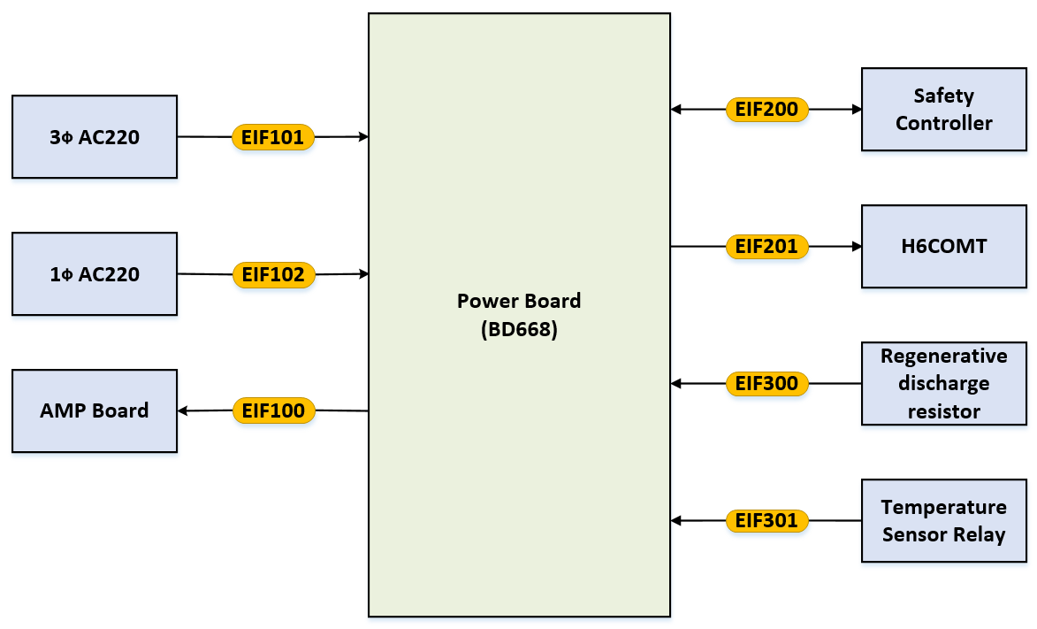

| **No.** | **Description** | **Items** | **Contents** |
| --- | --- | --- | --- |
| EIF100 | Power Output –Motor Operation Voltage | Type of data | Hardwiring(analog) |
| Exchanged data | Power |
| Data Range | DC 311V ± 25% |
| Refresh time of data | N/A(constant value) |
| EIF101 | Power Input – Input Motor Operation AC Voltage | Type of data | Hardwiring(analog) |
| Exchanged data | Power |
| Data Range | AC 220[V] ± 15% |
| Refresh time of data | N/A(constant value) |
| EIF102 | Power Input –Input Control AC Voltage | Type of data | Hardwiring(analog) |
| Exchanged data | Power |
| Data Range | AC 220[V] ± 15% |
| Refresh time of data | N/A(constant value) |
| EIF200 | Hardwired signal interfaces – PNUV, PNOV, DROH, DROC alarm signal, Pre-charge Relay/Discharge Relay Operation signal | Type of data | Hardwiring(analog) |
| Exchanged data | Discrete signals |
| Data Range | 0 ~ 15V ± 15% |
| Refresh time of data | N/A(constant value) |
| EIF201 | Hardwired signal interfaces – blackout signal | Type of data | Hardwiring(analog) |
| Exchanged data | Discrete signals |
| Data Range | 0 ~ 15V ± 15% |
| Refresh time of data | N/A(constant value) |
| EIF300 | Connecting to regenerative discharge resistor | Type of data | Hardwiring(analog) |
| Exchanged data | N/A(constant value) |
| Data Range | N/A(constant value) |
| Refresh time of data | N/A(constant value) |
| EIF301 | Connecting to Temperature sensor relay | Type of data | Hardwiring(analog) |
| Exchanged data | Discrete signals |
| Data Range | 0 ~ 24V ± 15% |
| Refresh time of data | N/A(constant value) |

#### Internal Interface

In the drawing, represents an external interface.



| **No.** | **Description** | **Items** | **Contents** |
| --- | --- | --- | --- |
| IIF100 | Analog Voltage – Comparator operating input voltage | Type of data | Analog signals |
| Exchanged data | Power |
| Data Range | 0 ~ 10[V] ± 15% |
| Refresh time of data | N/A(constant value) |
| IIF101 | Analog Voltage – PN PreCharge DC Voltage | Type of data | Analog signals |
| Exchanged data | Power |
| Data Range | 0 ~ 280[V] ± 15% |
| Refresh time of data | Less than 200msec |
| IIF102 | Analog Voltage – Regenerative IGBT gate signal | Type of data | Analog signals |
| Exchanged data | Power |
| Data Range | 0 ~ 15[V] ± 10% |
| Refresh time of data | Less than 200msec |
| IIF103 | Analog Voltage – Comparator output voltage  (overvoltage, undervoltage) | Type of data | Analog signals |
| Exchanged data | Power |
| Data Range | 0 ~ 15[V] ± 10% |
| Refresh time of data | Less than 50msec |
| IIF104 | Analog Signal – Temperature sensor relay input voltage | Type of data | Analog signals |
| Exchanged data | Power |
| Data Range | 0 ~ 15[V] ± 10% |
| Refresh time of data | Less than 50msec |
| IIF105 | Analog Signal – Pre-charge/Discharge Relay Operation signal | Type of data | Analog signals |
| Exchanged data | Power |
| Data Range | 0 ~ 24[V] ± 15% |
| Refresh time of data | Less than 50msec |

### AMP Board

세부 사양 내용이 반영된 AMP 보드의 System Block Diagram은 다음과 같으며, BD65A / BD65B 기준으로 작성되었다.

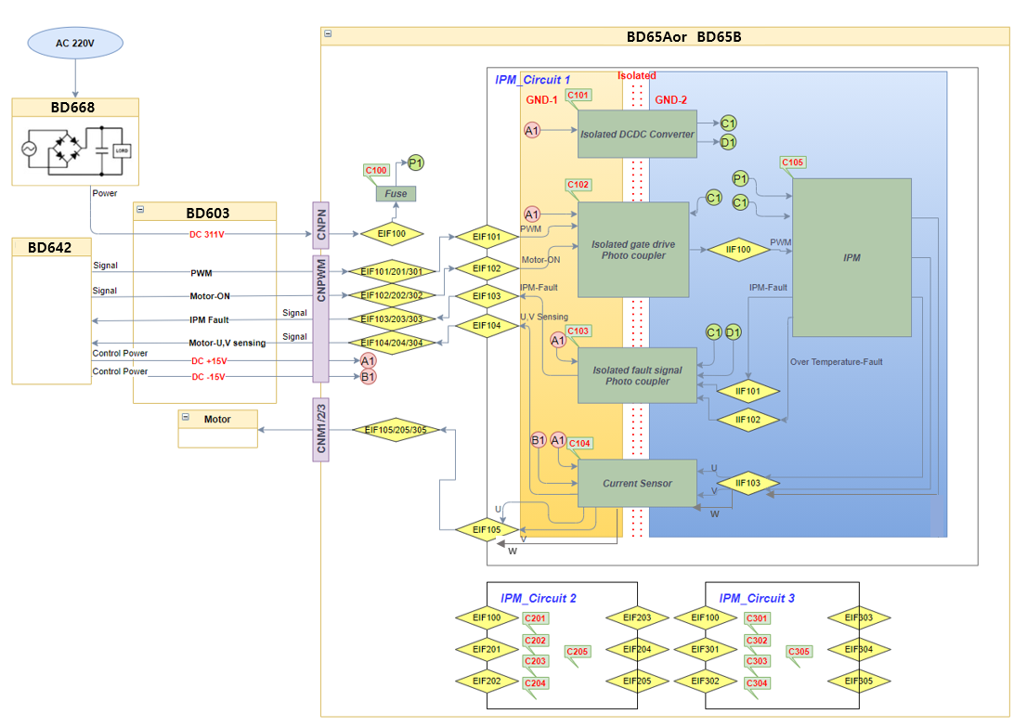

|  |  |  |  |
| --- | --- | --- | --- |
| No. | Components | Roles | Function |
| C100 | Fuse | IPM에 과도전류 인가 시 용단 | - |
| C101/201/301 | DC/DC Converter | 절연 전원 인가 | HF1 |
| C102/202/302 | High speed Photo-Coupler | IPM의 gating 신호 전달용 고속포토커플러 | HF2 |
| C103/203/303 | Normal Photo Coupler | Fault 신호 전달용 포토커플러 | HF3 |
| C104/204/304 | Current sensor | 모터 전류제어를 위한 전류피드백 센서 | HF4 |
| C105/205/305 | IPM | BD641T 보드의 전류지령에 대한 PWM 신호를 받아 모터 각 상에 전류를 흘려주는 전력증폭기능을 수행 | HF5 |

#### System Interfaces

##### External Interfaces

* 상기 System Block Diagram에서 기호는 외부 인터페이스를 나타낸다.

|  |  |  |  |
| --- | --- | --- | --- |
| **No.** | **Description** | **Items** | **Contents** |
| **EIF100** | Power interface - 311V(DC) power lines from BD602T and board. (BD667T receives 220V(AC) and makes 311V(DC).) | Type of data | Hardwiring (analog) |
| Exchanged data | Power |
| Data range | DC 0 ~ 311V ± 30% |
| I/O type | Input |
| Connector | CNPN |
| **EIF101**  **EIF201**    **EIF301** | Hardwired signal interfaces - Hardwired PWM wave for gating IPM | Type of data | Hardwiring (digital) |
| Exchanged data | Pulse Width Modulation |
| Data range | 0 ~ 15V ± 5% |
| I/O type | Input |
| Connector | CNPWM |
| **EIF102  EIF202**  **EIF302** | Hardwired signal interfaces - Hardwired Inputs for informing that Motor is on. (Depending on the situation based on the stop category, This signal is determined) | Type of data | Hardwiring (digital) |
| Exchanged data | Signal |
| Data range | 0 ~ 15V ± 5% |
| I/O Type | Input |
| Connector | CNPWM |
| **EIF103  EIF203  EIF303** | IPM-fault signal interfaces - Hardwired Outputs for informing when the IPM has a problem. (Failure due to IPM : internal short circuit, overheating) | Type of data | Hardwiring (digital) |
| Exchanged data | Signal |
| Data range | 0 ~ 15V ± 5% |
| I/O Type | Output |
| Connector | CNPWM |
| **EIF104  EIF204**  **EIF304** | Hardwired signal interfaces - Hardwired signal for current sensor of U and V-phase of motor. | Type of data | Hardwiring (analog) |
| Exchanged data | Signal |
| Data range | ± 4V ± 1.5% |
| I/O Type | Output |
| Connector | CNPWM |
| **EIF105  EIF205**  **EIF305** | Motor Power interface – U, V and W-phase of motor. | Type of data | Hardwiring (analog) |
| Exchanged data | Power |
| Data range | Voltage : ±311V ± 30%  Current is variable depending on the load |
| I/O Type | Output |
| Connector | CNM1, CNM2, CNM3 |

##### Internal Interfaces

* 상기 System Block Diagram에서 기호는 내부 신호의 전달체계에 대해 나타낸다.

|  |  |  |  |
| --- | --- | --- | --- |
| **No.** | **Description** | **Items** | **Contents** |
| **IIF100**  **IIF200**    **IIF300** | PWM wave for gating IPM | Type of data | Digital signal |
| Exchanged data | PWM gating pulse |
| Data range | 0 ~ 15V ± 5% |
| Signal sending side | C102/202/302 |
| Signal receving side | C105/205/305 |
| **IIF101  IIF201**  **IIF301** | IPM-fault signal (Failure due to IPM : internal short circuit) | Type of data | Discrete signals |
| Exchanged data | Fault ON/OFF |
| Data range | 0 ~ 5V ± 5% |
| Signal sending side | C105/205/305 |
| Signal receving side | C103/203/303 |
| **IIF102  IIF202  IIF302** | IPM-fault signal (Failure due to IPM : Overheating) | Type of data | Discrete signals |
| Exchanged data | Temperature values |
| Data range | 25°C : 1.1V ± 20%,  90°C : 2.7V ± 20% |
| Signal sending side | C105/205/305 |
| Signal receving side | C104/204/304 |
| **IIF103  IIF203**  **IIF303** | U, V, W-phase power of motor. | Type of data | Discrete signals |
| Exchanged data | U and V-phase power |
| Data range | Voltage : ±15V  Current is variable depending on the load |
| Power sending side | C105/205/305 |
| Power receving side | C104/204/304 |

##### Power

|  |  |  |  |
| --- | --- | --- | --- |
| **No.** | **Description** | **Power part** | **Where power is used** |
| **P1** | 311V(DC) | GND-2 | C105/205/305 |
| **A1/2/3** | +15V(DC) | GND-1 | C101/201/301  C102/202/302  C103/203/303  C104/204/304 |
| **B1/2/3** | -15V(DC) | GND-1 | C104/204/304 |
| **C1/2/3** | +15V(DC) | GND-2 | C101/201/301  C102/202/302  C103/203/303 |
| **D1/2/3** | +5V(DC) | GND-2 | C103/203/303 |

### Safety Communication Board

In the drawing,  represents an function block.



| **No.** | **Components** | **Roles** | **Function** |
| --- | --- | --- | --- |
| C400 | MCU1 | Perform safety-communication (Profi-safe) | - |
| C500 | MCU2 | Perform non-safety-communication (EtherCAT) |
| C401 | Oscillator(MCU1) | Provide clock source to MCU | - |
| C501 | Oscillator(MCU2) |
| C404 | OC Protection | Protects over-current(OC) in DC24V power source | - |

#### External Interface

In the drawing, represents an external interface.



| **No.** | **Description** | **Items** | **Contents** |
| --- | --- | --- | --- |
| EIF104 | Transmit safety-data using RS-485 interface to safe space 2.0 (:black-channel) | Type of data | RS485 signals |
| Exchanged data | Safe state of external device |
| Data Range | RS485 protocol |
| Refresh time of data | Less than 5msec |
| EIF108 | Transmit non-safety-data using EtherCAT to safe space 2.0 | Type of data | Ethernet signals |
| Exchanged data | Non-safe state of external device (ex. Digital Out signal, Digital In signal, Analog signal..) |
| Data Range | EtherCAT protocol |
| Refresh time of data | Less than 5msec |
| EIF401 | Transmit safety and non-safety-data using Profinet  (Perform safety-communication : Profi-safe) | Type of data | Profinet |
| Exchanged data | Safe and non-safe state, data of external device |
| Data Range | Profi-safe protocol |
| Refresh time of data | Less than 5msec |

#### Internal Interface

In the drawing, represents an external interface.

| **No.** | **Description** | **Items** | **Contents** |
| --- | --- | --- | --- |
| IIF401  IIF501 | Supplying clocks pulses to operate MCUs. | Type of data | Clock pulses |
| Exchanged data | Square pulse |
| Data Range | 0 ~ 3.3V ± 10% |
| Refresh time of data | 25MHz |
| IIF104 | XHIF – MCU1 send non-safety data to MCU2 for EtherCAT communication  (ex. Digital Out, IN, Analog data etc..) | Type of data | Ethernet signals |
| Exchanged data | Non-safe state of external device |
| Data Range | EtherCAT protocol |
| Refresh time of data | Less than 5msec |

# Detailed design

## Safety Controller

### Clock and MCU(: HF101)

#### Design Requirements

The requirements of MCU and its clock are as follows.

* + - The safety integrity levle of this function shall meet the requirements for PL d(SIL2), Cat.3.
    - To cross-check arithmetic results, MCUs shall have connected path each other.
    - The interface method between CPU1 is FSI, refer to CPU1_CPU1_IF of SRS.
    - The interface method between CPU2 is SCI, refer to CPU2_CPU2_IF of SRS.
    - The interface method between CM is CAN.
    - Clocks shall be used seperately for each channel. It is that one channel’s clock is not used in other channel.

#### Functional Description

The following figure illustrates the watchdog function.



* + - This function cross checks safety related data between MCUs.
    - In case of FSI communication, cross check is performed between CPU1s, SCI communication is cross checked between CPU2s and CAN communication is cross checked between CMs.
    - Each GPIO is used to implement a lock-step sequence.
    - All communications(FSI, SCI & CAN) and GPIO ports shall be isolated from other MCU.
    - In the event of an abnormal situation, buffer of STO output are shut down, making the robot system in safe-state.

#### Specification

* Oscillator

| **No.** | **Items** | **Contents** |
| --- | --- | --- |
|  | Manufacturer | SiTime |
| Part Number | SiT8208AI-G3-33E-25.000000T |
| Output Frequency | 25.0[MHz](±50PPM) |
| Supply Voltage | 3.3[V](±10.0%) |
| Duty Cycle | 45 ~ 55% |
| RMS Period Jitter | 2.0[ps](max 3.0[ps]) |

* Digital Isolation

| **No.** | **Items** | **Contents** |
| --- | --- | --- |
|  | Manufacturer | Texas Instrument |
| Part Number | ISO7763FQDBQRQ1 |
| Data Rate | Max. 100[Mbps] |
| Propagation delay time | 6.0 ~ 16.0[ns](Type 11.0[ns]) |
| High-level input voltage | 0.7*VCC ~ VCC (Our system VCC is 3.3[V]) |
| Low-level input voltage | 0.0 ~ 0.3*VCC (Our system VCC is 3.3[V]) |

* FSI

| **No.** | **Items** | **Items** | **Contents** |
| --- | --- | --- | --- |
|  | FSI(: Fast Serial Interface) – cross check data between the CPU1s. | Manufacturer | Texas Instrument |
| Part Number | TMS320F28388DZWT |
| Data Rate | Max. 50.0[Mbps] |
| Type of data | Discrete signals |
| Data Range | 3.3[V](±10.0%) |
| Refresh time of data | Less than 10msec |

* SCI

| **No.** | **Items** | **Items** | **Contents** |
| --- | --- | --- | --- |
|  | SCI(: Serial Communication Interface) – cross check data between the CPU2s. | Manufacturer | Texas Instrument |
| Part Number | TMS320F28388DZWT |
| Data Rate | Max. 3.0[Mbps] |
| Type of data | Discrete signals |
| Data Range | 3.3[V](±10.0%) |
| Refresh time of data | Less than 10msec |

* CAN

| **No.** | **Items** | **Items** | **Contents** |
| --- | --- | --- | --- |
|  | CAN(: Controller Area Network) – cross check data between the CMs. | Manufacturer | Texas Instrument |
| Part Number | TMS320F28388DZWT |
| Data Rate | Max. 1.0[Mbps] |
| Type of data | Discrete signals |
| Data Range | 3.3[V](±10.0%) |
| Refresh time of data | Less than 10msec |

### Watchdog function(: HF102)

#### Design Requirements

The requirements of watchdog function are as follows.

* + - The safety integrity levle of this function shall meet the requirements for PL d(SIL2), Cat.3. For detail, refer to SIM1, SIM2 of SRS.
    - In the event of an abnormal situation, buffer of STO output are shut down, making the robot system in safe-state.

#### Functional Description

The following figure illustrates the watchdog function.

* + - This function is to supervise a malfunction of MCUs. It uses the time-window-based watchdog pulse. If abnormal Situated, buffer of STO output are shut down.
    - Watchdog Output. Active low, The other MCU is detected by watchdog output. Then output buffer is disabled by ENDRVx(x=1,2).



#### Specification

* 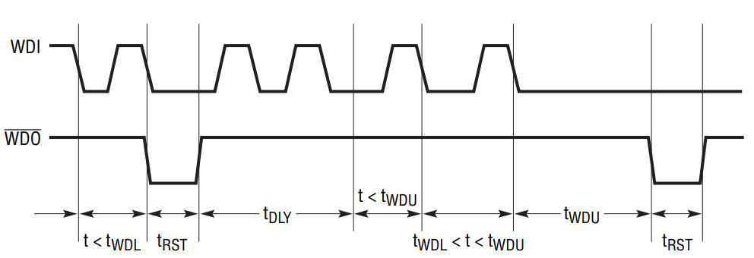Supervisor of Watchdog1

| **No.** | **Items** | **Contents** |
| --- | --- | --- |
|  | Manufacturer | Analog Devices |
| Part Number | LT3641EUFD |
| Watchdog Input Boundary | tWDL < x < tWDU  tWDL : 1.3[ms], tWDU : 20.72[ms] (when CWDT = 0.56[nF]) |
| Watchdog Start Delay Time | tDLY : 10.68[ms] |
| Watchdog Output Timeout Period | tRST : 20.72[ms] (when CPOR = 0.56[nF]) |
| Supply Voltage | 3.3[V](±10.0%) |

### Power supply function(: HF103)

#### Design Requirements and functional description

The requirements of power supply supervision function are as follows.

* + - The safety integrity level of this function shall meet the requirements for PL d(SIL2), Cat.3. For detail, refer to SIM3 of SRS.
    - The power input stage shall include protective measures against under-voltage, over-voltage and over-current.
    - All output voltages shall be monitoried so that the software can determine the abnormalities of the output voltage. In addition, each channel shall be able to cross-check the voltages.

The following figure illustrates the power supply supervision function.

* + - The power source used for control is DC24V and is supplied from external SMPS.



#### Required power

Predicted power in SafeSpace 2.0 is shown in table below.

* + - MCU1 & MCU2 parts

| **Circuits** | **Devices** | **3.3[V]** | **1.2[V]** |
| --- | --- | --- | --- |
| MCU | TMS320F28388D | 76.0mA | 478.0mA |
| MCU peripheral circuit | OSC | 33.0mA |  |
| LED | 3.3mA x 8 = 26.4mA |  |
| Watch Dog | TPS3820-33Q1 | 0.015mA |  |
| RS232 | SN65C3232E | 1.0mA |  |
| MEMORY | W25Q64JVX | 25.0mA |  |
| IS42S16800F | 100.0mA |  |
| AT24C16C | 5.0mA |  |
| EtherCAT | KSZ8061MNXIA | 28.0mA x 2 = 56.0mA |  |
| MCUs I/F | ISO7763FQDBQRQ1 | 8.6mA x 3 = 25.8mA |  |
| ADC | REF2030QDDCRQ1 | 0.5mA |  |
| TLV9154IDYYR | 0.2mA x 18 = 3.6mA |  |
| Temperature  Sensor | TMP235A | 0.015mA |  |
| DI | PS2805C | 0.75mA x 34 = 25.5mA |  |
| DO | AQY212S | 1.6mA |  |
| Total required Current | | About 379.43mA(per MCU) x 2 =  758.86mA | 478.0mA(per MCU) x 2 = 956.0mA |
| Total required Power | | 2504.238mW | 1147.2mW |
| Required power in DC24V | | DC24V / 153mA / 3652.0mW | |

* + - FPGA(ZYNQ7000) parts

| **Circuits** | **Devices** | **3.3[V]** | **1.35[V]** | **1.0[V]** | **1.8[V]** |
| --- | --- | --- | --- | --- | --- |
| MCU | XC7Z020-1CLG484I | 235.0mA | 7.0mA | 206.0mA | 51.0mA |
| MCU peripheral circuit | OSC | 33.0mA |  |  |  |
| LED | 3.3mA x 8 = 26.4mA |  |  |  |
| PWM BUFFER | SN74LS06DBR | 40.0mA x 10 =  400.0mA |  |  |  |
| RS232 | SN65C3232E | 1.0mA |  |  |  |
| MEMORY | W25Q512JVBIQ | 40.0mA |  |  |  |
| MT41K256M8DA-125I |  | 189.0mA x 2 =  378.0mA |  |  |
| AT24C16C | 5.0mA |  |  |  |
| EtherCAT | KSZ8061MNXIA | 28.0mA x 2 = 56.0mA |  |  |  |
| RS485 | ISO1430BDWR | 10.0mA x 8 = 80.0mA |  |  |  |
| DI | PS2805C | 0.75mA x 17 =  12.75mA |  |  |  |
| Total required Current | | 889.15mA | 385.0mA | 206.0mA | 51.0mA |
| Total required Power | | 2934.195mW | 519.75mW | 206.0mW | 91.8mW |
| Required power in DC24V | | DC24V / 157.0mA / 3751.745mW | | | |

External interface(I/O)

|  |  |  |  |  |  |
| --- | --- | --- | --- | --- | --- |
| **Circuits** | **Devices** | **24.0[V]** | **15.0[V]** | **-15.0[V]** | **5.0[V]** |
| DI | PS2805C | 5.0mA x 28 =  140.0mA |  |  |  |
| DO | AQY212S | 120.0mA x 2 =  240.0mA |  |  |  |
| PS2805C | 8.0mA x 20 =  160.0mA |  |  |  |
| Current Sensor | HC-PRC05V4B15 |  | 20.0mA x 24 =  480.0mA | 20.0mA x 24 =  480.0mA |  |
| Encoder | Sensor |  |  |  | 110.0mA x 8 =  880.0mA |
| ISO1430BDWR |  |  |  | 63.8mA x 8 =  510.4mA |
| Total required Current | | 540.0mA | 480.0mA | 480.0mA | 1390.4mA |
| Total required Power | | 12960.0mW | 7200.0mW | 7200.0mW | 6952.0mW |
| Required power in DC24V | | DC24V / 1430.0mA / 34312.0mW | | | |

Therefore, the required maximum power is more than DC24V / 1.74A / 41.7W. Also protective measures for each circuit shall be considered the maximum power. The recommanded specification of SMPS is shown in table below.

* + - Recommanded SMPS spec.

|  |  |  |
| --- | --- | --- |
| **Item** | **Specification** | **Remark** |
| Ambient temperature | -40 ~ 85 [℃] |  |
| Nominal output voltage | DC 24[V] ± 5% |  |
| Nominal output current | More than 2.0[A] |  |
| Residual ripple | < 100 mVpp(with nominal Values) |  |
| Output power | More than 50[W] |  |
| MTBF | > 1,000,000 h (40℃) |  |

#### Voltage Monitoring

Each regulated power shall be monitored by MCU. Monitored anlog ports are shown in the table below.

| **Channel** | **MCU port** | **Notation** | **Contents** | **Gain** | **Range** |
| --- | --- | --- | --- | --- | --- |
| MCU1  (Ch.1) | ADCINA0 | B_P24V_AIN | Internal Ch.2 Voltage | 0.0909 | 0.0~2.18V |
| ADCINA1 | BS_P24V_AIN | External IO Ch.2 Voltage | 0.0909 | 0.0~2.18V |
| ADCIND0 | BD_P3V3_AIN | MCU2 IO voltage | 0.5 | 0.0~1.65V |
| ADCIND1 | BD_P1V2_AIN | MCU2 core voltage | 0.9167 | 0.0~1.1V |
| ADCIN14 | B_P15V0_AIN | Current sensor voltage | 0.0909 | 0.0~1.36V |
| GPIO109 | B_N15V0_DIN | Current sensor voltage | - | Low / High |
| MCU2  (Ch.2) | ADCINA0 | A_P24V_AIN | Internal Ch.1 Voltage | 0.0909 | 0.0~2.18V |
| ADCINA1 | AS_P24V_AIN | External IO Ch.1 Voltage | 0.0909 | 0.0~2.18V |
| ADCIND0 | AD_P3V3_AIN | MCU1 IO voltage | 0.5 | 0.0~1.65V |
| ADCIND1 | AD_P1V2_AIN | MCU1 core voltage | 0.9167 | 0.0~1.1V |
| ADCIN14 | ZP3V3_AIN | ZynQ IO voltage | 0.5 | 0.0~1.65V |
| GPIO109 | A_P5V0_DIN | Encoder sensor voltage | - | Low / High |

The maximum rating of analog input voltages in MCU here is 3.6[V], so the specification of zener diodes used at input lines shall be less than 3.3[V].

Each analog inputs has a normal operation range as shown in the following table. The software shall ensure that all inputs are within normal range during self-diagnosis time, otherwise STO shall be activated.

|  |  |  |  |  |  |  |
| --- | --- | --- | --- | --- | --- | --- |
| **Channel** | **MCU port** | **Notation** | **Contents** | **Normal range /**  **monitoring value [V]** | | |
| **Min.** | **Typ.** | **Max.** |
| MCU1  (Ch.1) | ADCINA0 | B_P24V_AIN | Internal Ch.2 Voltage | 18 | 24 | 28 |
| 1.64 | 2.18 | 2.54 |
| ADCINA1 | BS_P24V_AIN | External IO Ch.2 Voltage | 18 | 24 | 28 |
| 1.64 | 2.18 | 2.54 |
| ADCIND0 | BD_P3V3_AIN | MCU2 IO voltage | 2.97 | 3.3 | 3.63 |
| 1.485 | 1.65 | 1.815 |
| ADCIND1 | BD_P1V2_AIN | MCU2 core voltage | 1.08 | 1.2 | 1.32 |
| 1.08 | 1.2 | 1.32 |
| ADCIN14 | B_P15V0_AIN | Current sensor voltage | 13.5 | 15.0 | 16.5 |
| 1.23 | 1.36 | 1.49 |
| GPIO109 | B_N15V0_DIN | Current sensor voltage | - | - | - |
| MCU2  (Ch.2) | ADCINA0 | A_P24V_AIN | Internal Ch.1 Voltage | 18 | 24 | 28 |
| 1.64 | 2.18 | 2.54 |
| ADCINA1 | AS_P24V_AIN | External IO Ch.1 Voltage | 18 | 24 | 28 |
| 1.64 | 2.18 | 2.54 |
| ADCIND0 | AD_P3V3_AIN | MCU1 IO voltage | 2.97 | 3.3 | 3.63 |
| 1.485 | 1.65 | 1.815 |
| ADCIND1 | AD_P1V2_AIN | MCU1 core voltage | 1.08 | 1.2 | 1.32 |
| 1.08 | 1.2 | 1.32 |
| ADCIN14 | ZP3V3_AIN | ZynQ IO voltage | 2.97 | 3.3 | 3.63 |
| 1.485 | 1.65 | 1.815 |
| GPIO109 | A_P5V0_DIN | Encoder sensor voltage | - | - | - |

### Encoder function(: HF104)

#### Design Requirements

The requirements of encoder diagnosis function are as follows.

* + - The safety integrity levle of this function shall meet the requirements for PL d(SIL2), Cat.3. For detail, refer to SIM4 of SRS.
    - In the event of an abnormal situation, buffer of STO output are shut down, making the robot system in safe-state.

#### Functional Description

The following figure illustrates encoder diagnosis function.

* + - The MCU acquires the encoder data using RS485 & EMIF as shown in the figure below.
    - The phase current(Iu,Iv,Iw) values are transferred to analog input ports of the MCU. The MCU converts analog signal to digital data with the ADC module.
    - The cross-check the theta value calculated from encoder data and phase current data(refer to SRS & SDS).
    - In the event of an abnormal situation, buffer of STO output are shut down, making the robot system in safe-state.



#### Specification

* RS485 Interface

| **No.** | **Items** | **Contents** |
| --- | --- | --- |
|  | Manufacturer | Texas Instruments |
| Part Number | ISO1430BDWR |
| Data Rate | Up to 12Mbps |
| Duplex | Half |
| Isolation Type | Galvanic Isolation |
| Supply Voltage | VCC1: 3.3[V](±10.0%), VCC2: 5.0[V](±10.0%) |

* Encoder

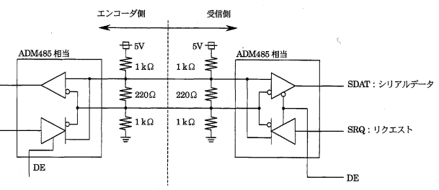

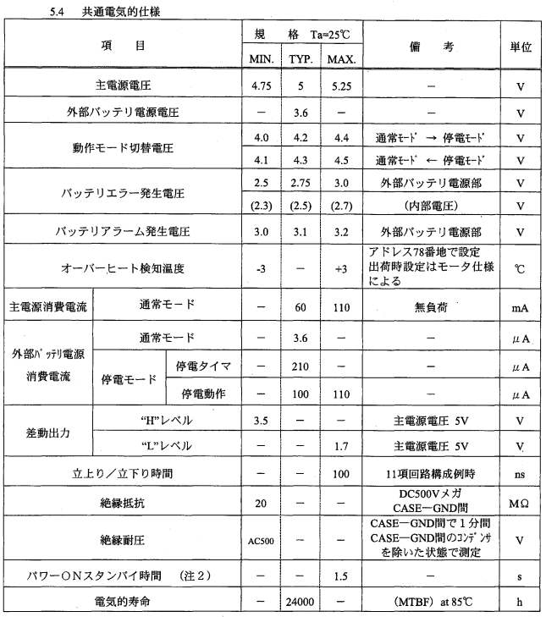

### Current sensor function(: HF105)

#### Design Requirements

The requirements of current sensor diagnosis function are as follows.

* + - The safety integrity levle of this function shall meet the requirements for PL d(SIL2), Cat.3. For detail, refer to SIM5 of SRS.
    - In the event of an abnormal situation, buffer of STO output are shut down, making the robot system in safe-state.

#### Functional Description

The following figure illustrates current sensor diagnosis function.

* + - The phase current(Iu,Iv) values are transferred to analog input ports of the MCU1. The MCU1 converts analog signal to digital data with the ADC module, then Iw calculated by MCU1(refer to SRS & SDS).
    - The phase current(Iv,Iw) values are transferred to analog input ports of the MCU2. The MCU2 converts analog signal to digital data with the ADC module, then Iu calculated by MCU2(refer to SRS & SDS).
    - The cross-check the phase current(Iu,Iv,Iw) values calculated from MCU1 & MCU2(refer to SRS & SDS).
    - In the event of an abnormal situation, buffer of STO output are shut down, making the robot system in safe-state.



#### Specification

* OP-AMP

| **No.** | **Items** | **Contents** |
| --- | --- | --- |
|  | Manufacturer | Texas Instruments |
| Part Number | TLV9154IDYYR |
| Gain & Type | In : -10.0 ~ +10.0[V]  Out : 0 ~ +3.0[V], Non-Reverse |
| Low Offset & High slew rate | ±125[㎶], 20[V/㎲] |
| Supply Voltage | 3.3[V](±10.0%) |

* ADC

| **No.** | **Items** | **Contents** |
| --- | --- | --- |
|  | Manufacturer | Texas Instruments |
| Part Number | TMS320F28388DZWT |
| Resolution | 12bits |
| Input Type | Single-ended Input |
| Conversion Time | 280[ns]  : Time between start of sample-and-hold window to start of sample-and-hold window of the next conversion. |
| Input Range | 0.0 ~ 3.0[V] |

* Current sensor

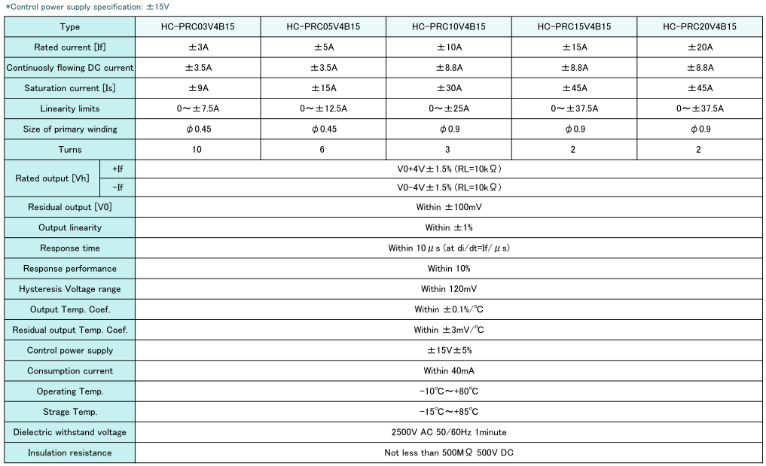

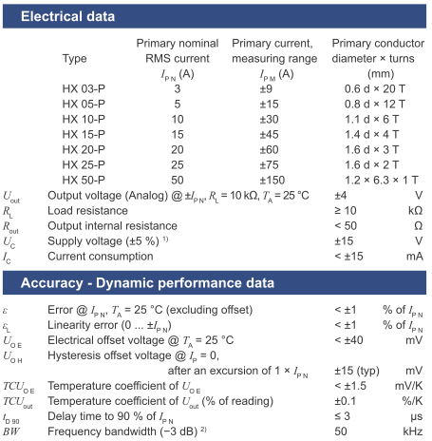

### Safety input function(: HF106)

#### Design Requirements

The requirements of safety input function are as follows.

* + Type.1(Up to PL e(SIL3), Cat.4)
    - The safety integrity levle of this function shall meet the requirements for below,

case 1 : single-channel mode(with test pulse) PL d(SIL2), Cat.2.

case 2 : dual-channel mode(without test pulse) PL d(SIL3), Cat.3.

case 3 : dual-channel mode(with test pulse) PL e(SIL3), Cat.4.

* + Type.2(Up to PL d(SIL2), Cat.3)
    - The safety integrity levle of this function shall meet the requirements for below,

case 1 : dual-channel mode(without test pulse) PL d(SIL2), Cat.3.

* + - All safety-related input ports shall be isolated from external lines.

For detail, refer to SIM6 to SRS.

#### Functional Description

The following figure illustrates safety-related digital input function.

* + - Case of dual-channel mode, the comparison of two channels are carried out in each MCU through the cross check.
    - In the event of an abnormal situation, buffer of STO output are shut down, making the robot system in safe-state.
  + Type.1(Up to PL e(SIL3), Cat.4)



* + Type.2(Up to PL d(SIL2), Cat.3)



#### Specification

Specifications of safety rated input ports are shown in the following table.

| **Type** | **Name** | **Usage** | **Range** | **Self-test Condition** |
| --- | --- | --- | --- | --- |
| Type.1. | A_OPEM1 | Emergency Stop input(Ch.1) | - Input voltage Range is from 16.0[V] to 28.0[V].  - Internal common ground input current [2.4mA@24V](mailto:2.4mA@24V) photocoupler input. | A_nOPEM1_T = LOW  A_nOPEM1_T_FDK = LOW |
| B_OPEM1 | Emergency Stop input(Ch.2) | B_nOPEM1_T = LOW  B_nOPEM1_T_FDK = LOW |
| A_TPEM1 | T/P Emergency Stop input(Ch.1) | A_nTPEM1_T = LOW  A_nTPEM1_T_FDK = LOW |
| B_TPEM1 | T/P Emergency Stop input(Ch.2) | B_nTPEM1_T = LOW  B_nTPEM1_T_FDK = LOW |
| A_TPEN1 | T/P Enable Switch input(Ch.1) | A_nTPEN1_T = LOW  A_nTPEN1_T_FDK = LOW |
| B_TPEN1 | T/P Enable Switch input(Ch.2) | B_nTPEN1_T = LOW  B_nTPEN1_T_FDK = LOW |
| A_nTPRMT | T/P remote state input(Ch.1) | The SW checks that only one of the three modes is selected and the status of the two channels is the same. |
| B_nTPRMT | T/P remote state input(Ch.2) |
| A_nTPMAN | T/P manual state input(Ch.1) |
| B_nTPMAN | T/P manual state input(Ch.2) |
| A_nTPAUTO | T/P automatic state input(Ch.1) |
| B_nTPAUTO | T/P automatic state input(Ch.2) |
| A_nSI1 | Safety-related input1(Ch.1) | A_nSI1_T = LOW  A_nSI1 = HIGH |
| B_nSI1 | Safety-related input1(Ch.2) | B_nSI1_T = LOW  B_nSI1 = HIGH |
| A_nSI2 | Safety-related input2(Ch.1) | A_nSI2_T = LOW  A_nSI2 = HIGH |
| B_nSI2 | Safety-related input2(Ch.2) | B_nSI2_T = LOW  B_nSI2 = HIGH |
| A_nSI3 | Safety-related input3(Ch.1) | A_nSI3_T = LOW  A_nSI3 = HIGH |
| B_nSI3 | Safety-related input3(Ch.2) | B_nSI3_T = LOW  B_nSI3 = HIGH |
| A_nSI4 | Safety-related input4(Ch.1) | A_nSI4_T = LOW  A_nSI4 = HIGH |
| B_nSI4 | Safety-related input4(Ch.2) | B_nSI4_T = LOW  B_nSI4 = HIGH |
| Type.2 | A_OPT_nSI1 | Option Safety-related input1(Ch.1) | None. |
| B_OPT_nSI1 | Option Safety-related input1(Ch.2) |
| A_OPT_nSI2 | Option Safety-related input2(Ch.1) |
| B_OPT_nSI2 | Option Safety-related input2(Ch.2) |
| A_OPT_nSI3 | Option Safety-related input3(Ch.1) |
| B_OPT_nSI3 | Option Safety-related input3(Ch.2) |
| A_OPT_nSI4 | Option Safety-related input4(Ch.1) |
| B_OPT_nSI4 | Option Safety-related input4(Ch.2) |
| A_OPT_nSI5 | Option Safety-related input5(Ch.1) |
| B_OPT_nSI5 | Option Safety-related input5(Ch.2) |
| A_OPT_nSI6 | Option Safety-related input6(Ch.1) |
| B_OPT_nSI6 | Option Safety-related input6(Ch.2) |
| A_OPT_nSI7 | Option Safety-related input7(Ch.1) |
| B_OPT_nSI7 | Option Safety-related input7(Ch.2) |
| A_OPT_nSI8 | Option Safety-related input8(Ch.1) |
| B_OPT_nSI8 | Option Safety-related input8(Ch.2) |

### Safety output function(: HF107)

#### Design Requirements

The requirements of safety output function are as follows.

* + Type.1(Up to PL e(SIL3), Cat.4)
    - The safety integrity levle of this function shall meet the requirements for below,

case 1 : dual-channel mode(without test pulse) PL d(SIL2), Cat.3.

case 2 : dual-channel mode(with test pulse) PL e(SIL3), Cat.4.

* + Type.2(Up to PL d(SIL2), Cat.3)
    - The safety integrity levle of this function shall meet the requirements for below,

case 1 : dual-channel mode(without test pulse) PL d(SIL2), Cat.3.

* + - All safety-related input ports shall be isolated from external lines.

For detail, refer to SIM7 to SRS.

#### Functional Description

The following figure illustrates safety output function.

* + Type.1(Up to PL e(SIL3), Cat.4)
    - The monitoring of safety ouput circuit include in output monitoring, test line output and feedback input as the figure below. This is only the diagram of one channel and another channel is the same.



* + Type. 2(Up to PL d(SIL2), Cat.3)
    - The monitoring of safety ouput circuit include in output monitoring as the figure below.



* + - This is only the diagram of one channel and another channel is the same.
    - The comparison of two channels are carried out in each MCU through the cross check.
    - If values of two channel are different, the MCU shall stop all safety-related operations.

#### Specification

Specifications of safety rated output ports are shown in the following table.

|  |  |  |  |  |  |
| --- | --- | --- | --- | --- | --- |
| **Type** | **Name** | **Usage** | **Range** | **Self-test Condition** | |
| Type.1. | A_SO1 | Safety-related output1(Ch.1) | - Output voltage Range is from 16.0[V] to 28.0[V].  - Internal common Vcc Max. output current 8mA@24V mosfet p-channel output | A_nSTO1_T = LOW  A_nSTO1_T_FDK = LOW | |
| B_SO1 | Safety-related output1(Ch.2) | B_nSTO1_T = LOW  B_nSTO1_T_FDK = LOW | |
| A_STO1 | Refer to 8.8 [SIM8] Monitoring of power contactor | | | |
| B_STO1 |
| Type.2. | A_OPT_SO1 | Option Safety-related output1(Ch.1) | - Output voltage Range is from 16.0[V] to 28.0[V].  - Internal common Vcc Max. output current 8mA@24V mosfet p-channel output | | None. |
| B_OPT_SO1 | Option Safety-related output1(Ch.2) |
| A_OPT_SO2 | Option Safety-related output2(Ch.1) |
| B_OPT_SO2 | Option Safety-related output2(Ch.2) |
| A_OPT_SO3 | Option Safety-related output3(Ch.1) |
| B_OPT_SO3 | Option Safety-related output3(Ch.2) |
| A_OPT_SO4 | Option Safety-related output4(Ch.1) |
| B_OPT_SO4 | Option Safety-related output4(Ch.2) |

### STO function(: HF108)

#### Design Requirements

The requirements of monitoring power contactor function are as follows.

* + - The safety integrity levle of this function shall meet the requirements for PL e(SIL3), Cat.4. For detail, refer to SIM8 of SRS.
    - The ports are isolated against external lines.

#### Functional Description

The following figure illustrates the monitoring of power contactor function.



* + - The monitoring of power contactor circuit include in STO output, STO output monitoring, test line output and feedback input as the figure below. This is only the diagram of one channel and another channel is the same.
    - The comparison of two channels are carried out in each MCU through the cross check.
    - If values of two channel are different, the MCU shall stop all safety-related operations.

### Temperature function(: HF109)

#### Design Requirements

The requirements of temperature monitoring function are as follows.

* + - This sensors have to be placed where appreciated.
    - The temperature sensor must be capable of measuring the temperature specificed in SIM9 of SRS 5. external environment and EMC(operating temperature 0.0℃ ~ 45.0℃).

#### Functional Description

The following figure illustrates the temperature monitoring function.

* + - Sensors transduce temperature into electrical analog signal.
    - Temperature vales in 1 positions are transfered to analog input ports of the MCU.
    - The MCU converts analog signal to digitial signal with the ADC module.
    - The MCU periodically monitors if the board is over-heated.
    - If temperature is over than spec, the MCU shall stop all safety-related operations.



#### Specification

* Temperature Sensor

| **No.** | **Items** | **Contents** |
| --- | --- | --- |
|  | Manufacturer | Texas Instruments |
| Part Number | TMP235A2DCKR |
| Accuracy | ±2.5℃: -40.0 ~ 150.0℃ |
| Supply Voltage | 3.3[V](±10.0%) |

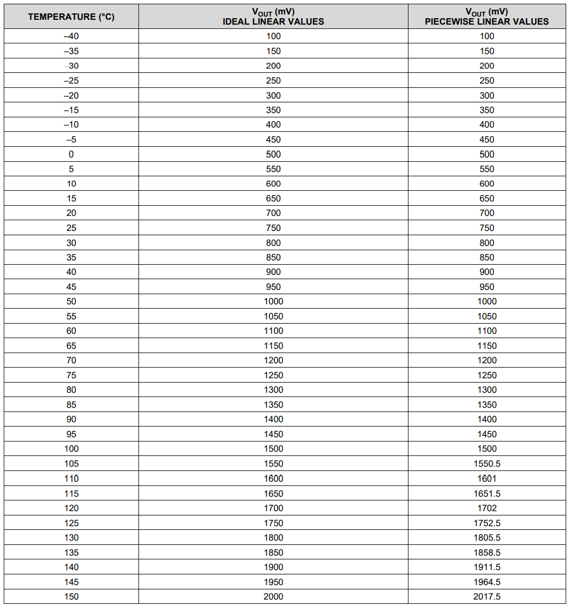

### EMIF function(: HF110)

#### Design Requirements

The requirements of EMIF function are as follows.

* + - SDRAM should not be sufficient in consideration of the amount of code and operation of the MCUs.
    - For interface data and requirements between MCU1 & ZYNQ(FPGA), refer to SC_SV_IF of SRS.

#### Functional Description

The following figure illustrates the EMIF function.

* + - EMIF enables access by the MCU and supports synchronous and asynchronous mode.
    - It provides 16bits data bus, 15bits address, chip select, read strobe, write strobe and wait control.
    - The EMIF between MCU1 and ZYNQ(FPGA) interfaces in asynchronous mode, and the EMIF between MCUs and SDRAM interfaces in synchronous mode.



#### Specification

* EMIF(MCU1 & ZYNQ(FPGA))

| **No.** | **Items** | **Contents** |
| --- | --- | --- |
|  | Manufacturer | MCU: Texas Instruments  ZYNQ: Xillinx |
| Part Number | MCU: TMS320F28388DZWT  ZYNQ: XC7Z020-1CLG484I |
| Mode | Asynchronous Mode |
| Clock Frequency Rate | Max. 200MHz |
| Memory Size | Chip Select 2: 2Mbits X 16  Chip Select 3: 512Kbits X 16 |
| Supply Voltage | 3.3[V](±10.0%) |

* EMIF(MCUs & SDRAM)

| **No.** | **Items** | **Contents** |
| --- | --- | --- |
|  | Manufacturer | MCU: Texas Instruments  SDRAM: ISSI |
| Part Number | MCU: TMS320F28388DZWT  SDRAM: IS42S16800F-6BLI |
| Mode | Synchronous Mode |
| Clock Frequency Rate | Max. 166MHz |
| Memory Size | 8Mbits X 16 |
| Supply Voltage | 3.3[V](±10.0%) |

|  |  |  |
| --- | --- | --- |
| **MCU1, MCU2** | **SDRAM** | **ZYNQ(FPGA)** |
|  |  |  |

### Brake control function(:HF111)

#### Design Requirements

The requirements of brake control function are as follows.

* + - The safety integrity levle of this function shall meet the requirements for PL d(SIL2), Cat.3. For details, refer to SF18 of SRS.
    - For brake control interface, refer to SC_PC_IF2 of SRS.
    - All brake release output and monitoring input ports shall be isolated from brake lines.
    - Brake power is supplied separately from control power. For details, refer to BP_IF of SRS.

#### Functional Description

The following figure illustrates brake control function.

* + - Brake release is operated using the digital output of MCU1, and Brake release signal is monitored using the digital input of MCU2.
    - The brake is an inductance component, and when the power is turned off, reverse voltage is generated. To protect the controller due to this, a diode for freewheeling, a zener diode for suppression, and a fuse were designed.



#### Specification

* Photo Coupler(side output port)

| **No.** | **Items** | **Contents** |
| --- | --- | --- |
|  | Manufacturer | RENESAS |
| Part Number | PS2802C-4 |
| Output Type | Darlington Transistor |
| Current Transfer Rate | 200 ~ 1000[%] |

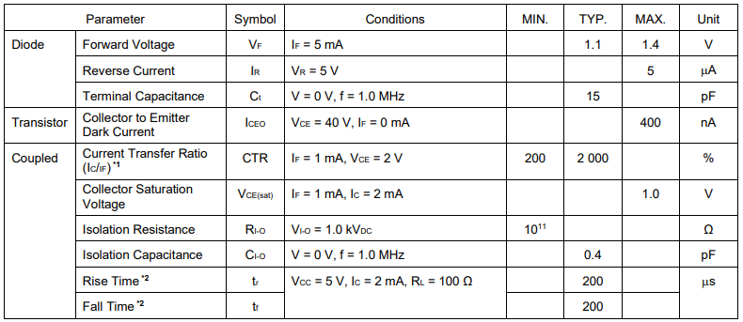

* Photo Coupler(side input port)

| **No.** | **Items** | **Contents** |
| --- | --- | --- |
|  | Manufacturer | RENESAS |
| Part Number | PS2805C-4 |
| Output Type | NPN Transistor |
| Current Transfer Rate | 100 ~ 400[%] |

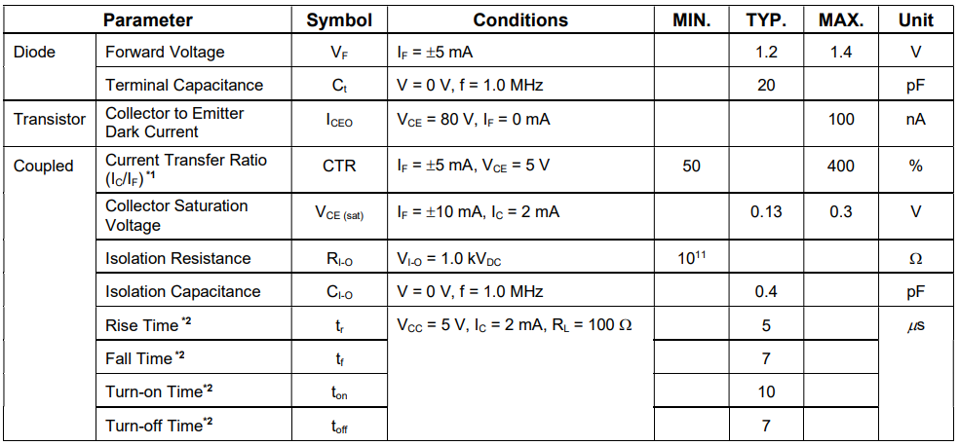

* Brake

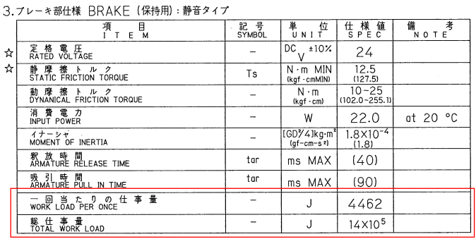

### EtherCAT function(:HF112)

#### Design Requirements

The requirements of EtherCAT function are as follows.

* + - EtherCAT schamatic consist of black channels. For detail, refer to SF16 of SRS.
    - For the interface between main controller and MCU1, refer to MN_SC_IF1~4 of SRS.
    - For the interface between main controller and ZYNQ(FPGA), refer to MN_SV_IF1 of SRS.

#### Functional Description

The following figure illustrates the EtherCAT function.

* + - The interface between MCU1 and PHY is MII(media independent interface). Also, the interface between ZYNQ(FPGA) and PHY is the same.
    - Signals between PHY controller and RJ45 are designed 100[ohm] differential pair pattern for impedance matching.
    - The RJ45 has a built-in pulse transformer, so it is galvanic isolated from EtherCAT signals.



#### Specification

* Pulse Transformer

|  |  |
| --- | --- |
|  |  |

### AMP board interface function(:HF113)

#### Design Requirements

The requirements of AMP board interface function are as follows.

* + - Signals interfaceing with AMP board are PWM gating signals, IPM fault signals and current sensor siganls.
    - PWM gating signals and IPM fault signals are non-safety signals. Refer to SV_AM_IF1, SV_AM_IF2 of SRS.
    - For current sensor signals interface, refter to SC_AM_IF of SRS.

#### Functional Description

The following figure illustrates AMP board interface function.

* + - The buffer of the PWM gating signal is an open-collector tiype inverting buffer. In addition, frequency characteristics of 10[kHz] or more are required.
    - All IPM fault input ports shall be isolated from AMP board lines.



#### Specification

* Buffer

| **No.** | **Items** | **Contents** |
| --- | --- | --- |
|  | Manufacturer | Texas Instruments |
| Part Number | SN74LS06DBR |
| Switching Spec. | Active High : 7.0 ~ 15.0[ns]  Active Low : 10.0 ~ 20.0[ns] |
| Output Type | Open-collector(max. 30V) |
| Supply Voltage | 3.3[V](±10.0%) |

|  |  |
| --- | --- |
|  |  |

### Power control board interface function(: HF114)

#### Design Requirements

The requirements of power control board interface function are as follows.

* + - The signals interfacing with the power control board are under-voltage and over-voltage of the DC Link, pre-charge control and monitoring signals.
    - The power control board is non-safety parts.

#### Functional Description

The following figure illustrates the power control board interface function.

* + - The under-voltage and over-voltage signal are input as a digital signal of ZYNQ(FPGA), also regenerative resistor over-heat and connect-status signal are input as a digital signal of ZYNQ(FPGA).
    - The pre-charge control signal is output as a digital signal of MCU1 and the pre-charge monitoring signal is input as a digital signal of MCU2.



#### Specification

Specifications of inteface signals are shown in the following table.

| **No.** | **Name** | **Usage** | **Range** | **Condition** |
| --- | --- | --- | --- | --- |
|  | EX_PNOV | DC-Link Over-voltage input | Internal common ground input current 2.7mA/15V  hotocoupler input | EX_PNOV = LOW  Z_PNOV = LOW |
| EX_PNUV | DC-Link Under-voltage input | EX_PNUV = LOW  Z_PNUV = LOW |
| EX_nRYON | Pre-charge ON/OFF output | A_nRYON = LOW  EX_nRYON = LOW |
| EX_RYON_FDK | Pre-charge monitoring input | EX_RYON_FDK = HIGH  B_nRYON_FDK = LOW |
| EX_DROH | regenerative resistor over-heat input | EX_DROH = LOW  Z_DROH = LOW |
| EX_DMOH | regenerative resistor connection-status  input | EX_DMOH = LOW  Z_DMOH = LOW |

### Safety communication board interface function(: HF115)

#### Design Requirements

The requirements of safety communication board interface function are as follows.

* + - Safety communication board interface schamatic consist of black channels, refer to EXT_IF1 of SRS.
    - The interface of this function is RS485 communication.

#### Functional Description

The following figure illustrates safety communication board interface function.

* + - RS485 transceiver is Tx enable/disable controlled.
    - The terminal resistance is designed to be 120[ohm].
    - The protection circuit is designed for RS485 dedicated TVS(Transient Voltage Suppressor).



#### Specification

* RS485 Transceiver

| **No.** | **Items** | **Contents** |
| --- | --- | --- |
|  | Manufacturer | Texas Instruments |
| Part Number | THVD1420DRLR |
| Data Rate | Up to 12[Mbps] |
| Supply Voltage | 3.3[V](±10.0%) |

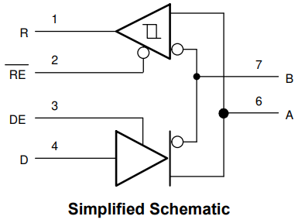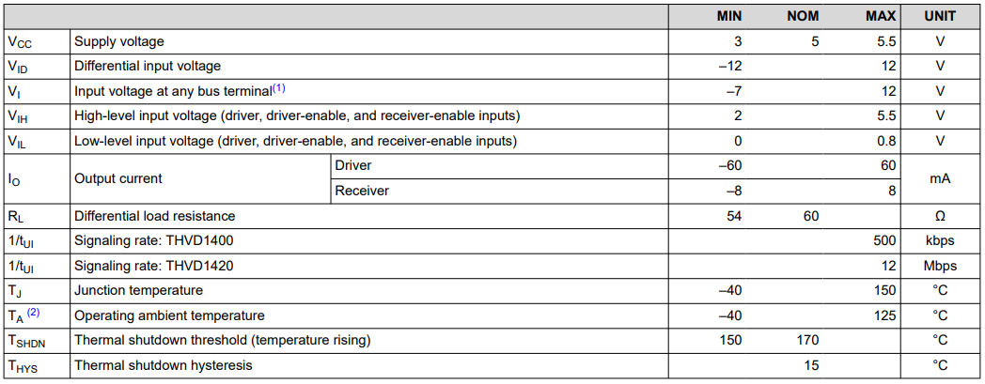

* TVS

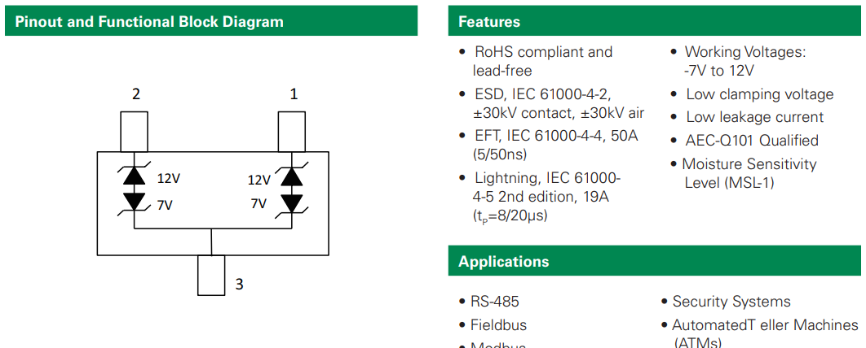

## Power Control Board

#### HF201: AC to DC Rectifier function

* + - AC220V 3-phase power is applied and converted to 311 V DC voltage to supply the motor driven main power.
    - Diode Module specification (3-phase bridige Rectifier + IGBT chopper)

| **No.** | **Items** | **Contents** |
| --- | --- | --- |
|  | Manufacturer | Semikron |
| Part Number | SK 95 DGL 126 |
| Rectifier Peak Voltage | 1600[V] |
| Rectifier Rated Current | 96[A], Ts = 80[oC] |
| Rectifier Operation Temperature | -40 ~ 150[oC] |

| **No.** | **Items** | **Contents** |
| --- | --- | --- |
|  | Manufacturer | Semikron |
| Part Number | SK 95 DGL 126 |
| Rectifier Peak Voltage | 1200[V] |
| Rectifier Rated Current | 140[A], Ts = 80[oC] |
| Rectifier Operation Temperature | -40 ~ 125[oC] |

* + - Designe circuit

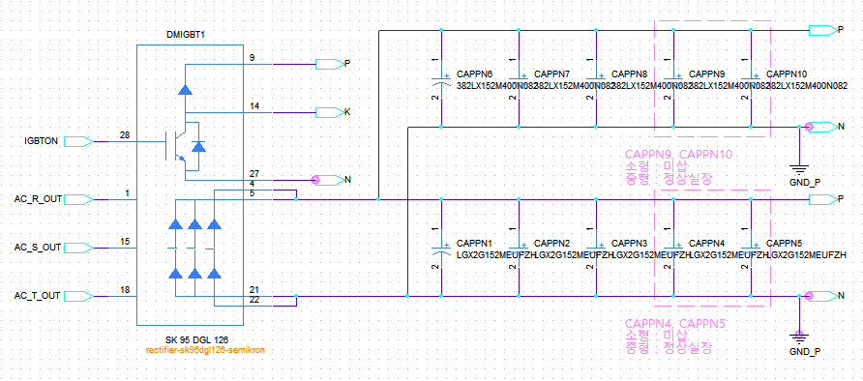

#### HF202: PN Voltage discharge function

* + - This is a function that discharges the PN voltage through a relay when the servo is off, and if the fast discharge is not performed while being charged in the capacitor of the high voltage, the operator may have a risk of electric shock.
    - Discharge Specification

| **No.** | **Items** | **Contents** |
| --- | --- | --- |
|  | Dischage operation Time | Within 60[s] |
| Dischage Resistor | RQR 20, 5.1k [ohm] |

* + - Discharge Relay

| **No.** | **Items** | **Contents** |
| --- | --- | --- |
|  | Manufacturer | Panasonic |
| Part Number | SFS3-L-DC24V |
| Contact arrangement | 3 From A, 1 From B |
| Nominal coil voltage | 24[Vdc] |
| Rate max switching voltage | 250[Vac] |
| Rate max switching current | 6[A] |

* + - Design circuit
    - LED3 represents the state of the discharge relay operation.

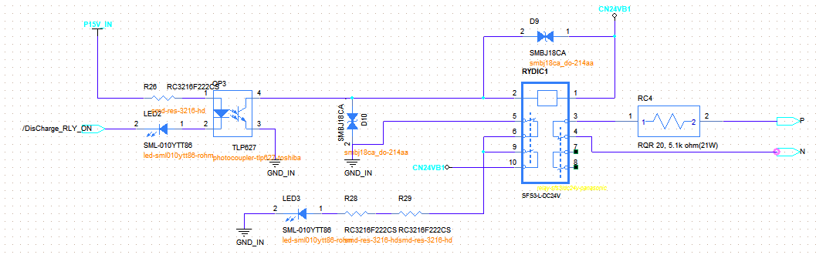

#### HF203: PN Overvoltage detection function

* + - It is a function of detecting a state in which a DC voltage for driving an inverter exceeds a set value, and sets a detection voltage designed with a variable resistance. It is detected when the regenerative discharge function fails or an overvoltage exceeding the discharge performance occurs.
    - Overvoltgae detection Specification

| **No.** | **Items** | **Contents** |
| --- | --- | --- |
|  | Overvoltage detection voltage range | 395[V] ± 5%, start voltage : 385[V] |
| Check the fault input signal | +15[V] |

* + - 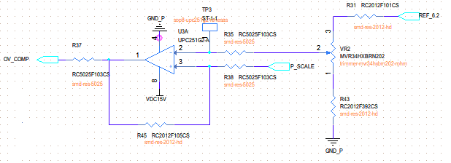Deisgne circuit
    - Comparing the voltage (a) divided by the PN voltage with the voltage (b) set by VR2, (a) when the voltage is high, the U3 output becomes High and outputs an error.
    - 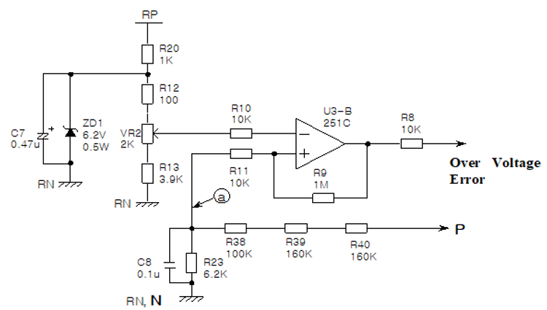The VR2 setting range is 4.03[V] to 6.1[V], and the setting range of the overvoltage detection voltage is 290.0[V] to 439.0[V]. R9, R10 are intended to create hysteresis properties and prevent chattering.

#### HF204: PN Undervoltgae detection function

* + - It is a function of detecting a state in which a DC voltage for driving an inverter is lowered below a set value, and a detection voltage designed with a variable resistance is set.
    - Undervoltgae detection Specification

| **No.** | **Items** | **Contents** |
| --- | --- | --- |
|  | Overvoltage detection voltage range | 140[V] ± 5%, Start voltage : 130[V] |
| Check the fault input signal | +15[V] |

* + - 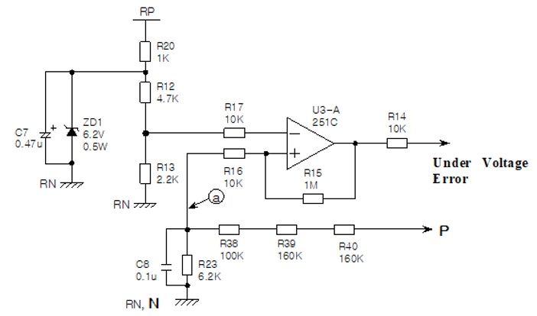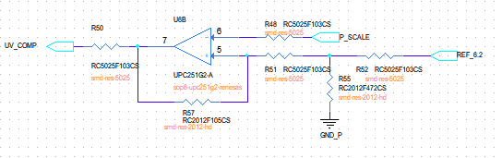Deisgne circuit
    - The voltage (a) divided by the PN voltage is compared with the set voltage, and when the voltage (a) is low, the output of U3 becomes high to output an error. The low voltage detection setting value is 140[V].

#### HF205: Regenerative discharge control function

* + - It protects the power device by discharging the DC voltage through the resistor when the DC voltage rises due to the power generated from the motor, and the discharge start voltage and the discharge end voltage are set with the variable resistance.
    - IGBT specification

| **No.** | **Items** | **Contents** |
| --- | --- | --- |
|  | Manufacturer | Semikron |
| Part Number | SK 95 DGL 126 |
| IGBT Peak Voltage | 1200[V] |
| IGBT Rated Current | 32[A], Ts = 80[oC] |
| IGBT Gate Voltage | ±20[V] |
| Rectifier Operation Temperature | -40 ~ 150[oC] |

| **No.** | **Items** | **Contents** |
| --- | --- | --- |
|  | Manufacturer | Semikron |
| Part Number | SKD 146/12-L140 T4 |
| IGBT Peak Voltage | 1200[V] |
| IGBT Rated Current | 120[A], Ts = 80[oC] |
| IGBT Gate Voltage | ±20[V] |
| Rectifier Operation Temperature | -40 ~ 125[oC] |

* + - 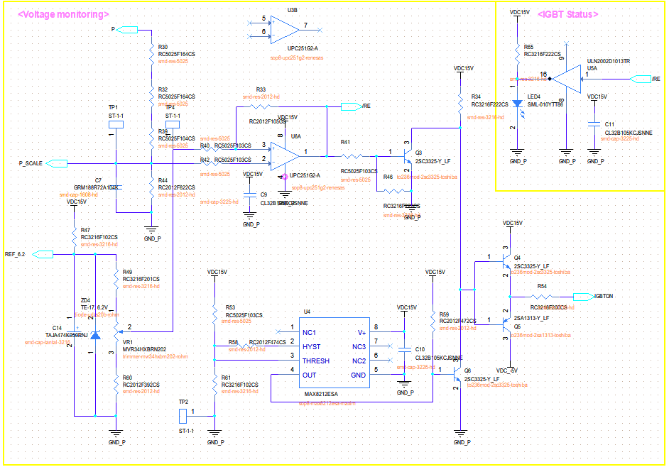Deisgne circuit

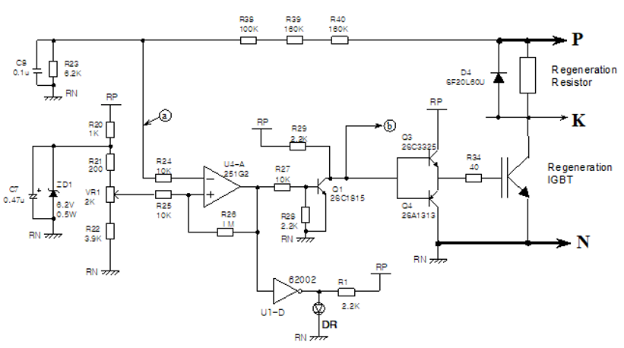

* + - A regenerative control circuit requires a separate power supply that is isolated from the control power supply, and is configured with a voltage loop power circuit to prevent changes in the analog setting value of the regenerative control circuit.

#### HF206: Regenerative discharge resistance overheating detection function

* + - Operation detection function of the superheated temperature sensor attached to the regenerative discharge resistance
    - 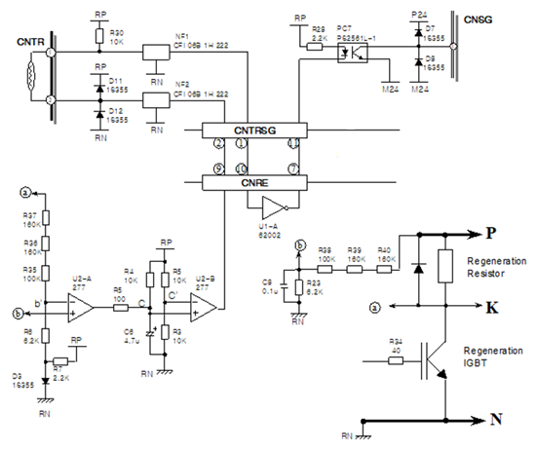Design circuit
    - Regenerative discharge resistance Specification

| **No.** | **Items** | **Contents** |
| --- | --- | --- |
|  | Rate power | 500[W]/3000[W] |
| resistance | 15[Ohm]/5[Ohm] |

* + - In a state in which regeneration does not occur, as the voltage of b′ is higher than the voltage of b by the diode forward voltage drop (0.7[V]), the power of the comparator U2 becomes low and the potential of c point is 0.7[V].

#### HF207: Regenerative discharge resistance open circuit detection function

* + - Open circuit detection of regenerative discharge resistance
    - Design circuit
    - When the regenerative resistance is disconnected, the a-point potential floats, so the b'potential is zero, the comparator U2 output becomes high by comparing the b'potential with the b'potential, and the c-point potential becomes RP, and the B2 output is high to turn on the PC7 output by the inverted furnace.

#### HF208 Pre-Charge Function

* + - In order to reduce the in-rush current of the capacitor to charge the PN voltage, the pre-charge relay is driven by motor on/off sequence control and the result is feedback to BD642A.
    - Pre-charge Specification

| **No.** | **Items** | **Contents** |
| --- | --- | --- |
|  | Pre-charge operation Time | Within 300[ms] |
| Pre-charge Resistor | RQR 20, 30 [ohm] |

* + - Pre-charge Relay

| **No.** | **Items** | **Contents** |
| --- | --- | --- |
|  | Manufacturer | Panasonic |
| Part Number | SFS3-L-DC24V |
| Contact arrangement | 3 From A, 1 From B |
| Nominal coil voltage | 24[Vdc] |
| Rate max switching voltage | 250[Vac] |
| Rate max switching current | 6[A] |

* + - Design circuit
    - At the time of initial main power input, a large inrush current flows purely in the main capacitor for smoothing because the DC Link terminal voltage generating circuit becomes short-circuited at the moment of starting charging. To prevent this, an inrush current limiting circuit as shown in the figure below was configured.

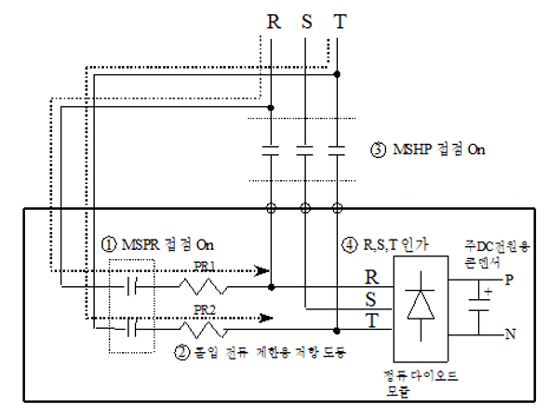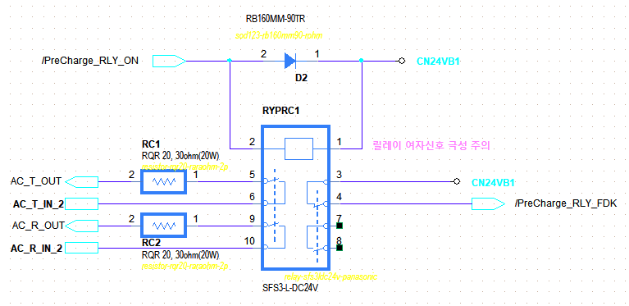

#### HF209 Blackout detection Function

* + - When a power failure of the AC input power source is detected, the buffer maintains a voltage of DC12V or higher for 1 second, and the main module (H6COM-T) backs up during this predetermined time.

※ The driving voltage specification of the H6COMT is 12 to 24V, and the data backup requirement is 1 second.

* + - Blackout detection Specification

| **No.** | **Items** | **Contents** |
| --- | --- | --- |
|  | Blackout detection Time | |  |  |  |  | | --- | --- | --- | --- | | Switch Number(SW2) | 1 | 2 | Time | | Long Mode | OFF(45%) | OFF(3 cycles) | Within 40[ms] | | Short Mode | ON(70%) | ON(1.5 cycles) | Within 70[ms] | |

* + - 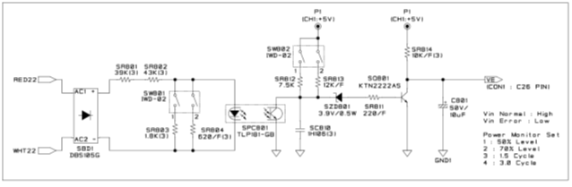Design circuit

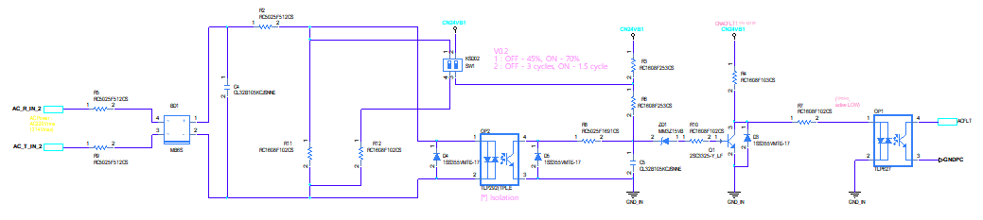

## AMP Board

### 설계 배경

#### 로봇을 위한 모터타입 선정

* PMSM(Permanent Magnet Synchronous Motor)는 고속운전 및 정밀 위치제어가 가능하고 높은 토크를 발생시키며 효율이 좋기 때문에 산업용로봇과 같은 다관절로봇에서 활용되기 적합한 모터이다.
* 그 중 우리는 200V용 PMSM을 채택하였으며, 그 이유는 다음과 같다.
  + 공장전원 대응 : 산업용로봇과 같이 공간이 제한되고 고정된 환경에서 하기와 같은 공장전원 전압레벨에 대응되야 한다. 자사 제어기는 트랜스포머를 활용하여 공장전원을 200V 교류전원으로 출력된 3상전원을 제어기 구동원으로 입력받아 모터를 구동한다.
    1. 북미는 480V / 277V, 일본은 200V / 208V, 유럽은 380V / 400V / 415V, 남미 및 한국은 220V / 380V를 사용함
  + 고출력 / 고토크 : 고가반 시리즈의 협동로봇 라인업을 위함
  + 높은 속도 : 기존 산업용로봇에 대응되는 높은 속도의 출력을 내기 위함.

#### 전력변환 토폴로지

* 공장전원 -> 트랜스 -> 3상 교류 200V변환 -> DC링크 -> 인버터 -> 로봇의 각 축 모터 **(그림 넣을 것)**
* 200V로 변환된 3상 교류전원을 DC링크를 거쳐 인버터로 출력하는 이유는 다음과 같다.
  + 3상 교류전원을 (예시 AC 200V, 60Hz) 모터에 직접 공급하면 고정된 전압/주파수로만 작동되어야 하며, 직렬연결한 상태에서 전압 및 주파수를 가변하는 제어방식은 더 어려울 뿐만 아니라 전력변환 효율이 감소됨
  + 이를 개선하기 위해 AC 상용전원을 DC링크에 저장해 놓고 인버터를 사용하면, 제어신호를 통해 모터의 출력을 보다 쉽게 조절 가능하며 인버터의 스위칭 손실만 발생

#### IPM (Intelligent Power Module) for Inverter of AMP Board

* 기존 스위칭 파워소자 대비 IPM을 사용하는 이유는다음과 같다.
  + 모터 제어성능 향상 (고성능화, 대용량화, 저소음화, 안전성, 신뢰성), 고전압/고전류 고열처리, 노이즈 처리기술이 집약된 전력반도체
  + 기존 스위칭 파워소자(Tr, MOSFET) 대비 단위 면적당 허용전류 용량 높음
  + 검증된 게이트드라이버와 각종 보호회로가 내장

#### IPM 선정

* Hi6-A 제어기 AMP Board의 IPM은 상기 전력변환 토폴로지에 기반한 전압, 전류 사양을 검토하여 선정했다.

1. Voltage

* DC-Link Voltage : 220V x [√2 x 1.1+ 회생에너지에 의한 전압증가분](https://namu.wiki/w/%E2%88%9A2)
* 회생에너지에 의한 직류전압 증가분은 컨버터부의 회생방전 제어를 통해 제한한다
* DC-Link 전압 최대치 : 395V, 과전압에러 검지 레벨

1. Current

* 로봇에 적용된 모터의 정격전류 및 최대전류 사양은 아래와 같다.

|  |  |  |  |  |  |  |
| --- | --- | --- | --- | --- | --- | --- |
| Motor Models | Applied  amount  [EA] | Motor Rated Output  [W] | Motor Rated current  [Arms] | Motor Stall current  [Arms] | Motor Peak current  [Arms] | Robot Peak current  [Apeak] |
| TSM3506 N7021 E731 | 2 | 2300 | 8.9 | 8.4 | 25.6 | - |
| TSM3563 N7020 E731 | 1 | 1500 | 9.4 | 8.5 | 20.5 | - |
| TSM3303 Series | 3 | 600 | 5 | 4.6 | 16.6 | - |
| Sum | 6 | 7900 |  |  |  |  |

표 . 35kg 가반하중 로봇의 현 모터 스펙 (’23.01.17 기준, **향후 기구개발 형태에 따라 수정될 수 있음**)

1. 선정 IPM

* 주축(1~3번) : PSS50SA2F6 또는 PSS75SA2F6 (Large 시리즈 / 50A,75A / 600V / 2500Vrms 절연전압)
* 수축(4~6번) : PSS35S92E6 (Super mini 시리즈 / 35A / 600V / 1500Vrms 절연전압)

#### 전류센서 선정 및 전류파라미터 허용치 검토

* 전류센서의 센싱 범위가 로봇의 축별 Motor의 설계된 Peak Current 이상을 만족하는지 여부를 사전에 확인하여 선정해야 한다.
* 하기 표는 주축 전류센서 및 수축 전류센서를 용량별로 구분하여 사용하였을 때 자사 제어시스템에서 최대 전류측정 레벨 범주를 대략적으로 파악할 수 있다.
* 이를 통해 로봇의 Motor에 따라 AMP의 IPM과 전류센서가 적절하게 매칭되어 사용한다.

* 계산치에는 허용치 레벨의 최대값에 마진을 포함하여 계산되었다.

|  |  |  |  |  |  |
| --- | --- | --- | --- | --- | --- |
| 드라이브  Models | Hall Sensor 전류스펙  [A] | 전류센서  Full Scale 스펙(마진고려)  [B=2*A*7.5/8] | 적용 IPM  전류 최대치 사양  [C] | 자사 제어시스템  허용 최대 전류  (최대값, 마진고려)  [D=Min{2*A/1.1, C/1.1}] | 자사 제어시스템  허용 최대 전류 (최소값, 마진고려)  [E=2*A*0.4/1.1] |
| 중형 6축 | 50 | 93.75A | 100 A | 90.91A | 36.36A |
| 75A | 68.18A | 36.36A |
| 25 | 46.87A | 75A | 45.45A | 18.18A |
| 50A |
| 소형 6축 | 15A | 28.12A | 50A | 27.27A | 10.91A |
| 5A | 9.37A | 20A | 9.09A | 3.64A |

표. 서보 AMP 사양에 따른 전류파라미터 관계

#### AMP설계 반영될 규정항목

* 드라이브모듈 설계는 IEC 61508에서 파생된 IEC 61800-5 안전 표준을 참고하여 design을 진행한다. IEC 61800-5-1/2는 Adjustable-speed electrical power drive system에 대한 안전 표준규정이다. 이 표준은 전기적, 온도, 에너지에 대한 안전에 대해 나타낸다. 이를 통해 다음과 같은 3가지 설계사항이 반영되어야 한다.
* Isolation 반영 : 50V 이상의 High voltage에 대한 DC-Link 전원단, AMP의 인버터단을 제어하는 Gate driver, 전압/전류피드백 신호 전달
* IEC 60201-1에서 정의된 정지 카테고리 0/1/2 정지신호에 따른 인버터의 gate 제어
* 인버터의 Fault 신호 전달 (IPM 내부 IGBT의 상/하단 단락감지, 온도과열, 제어전원 저하)

### 절연 (HF301)

#### 고려사항 요약

* IEC 61800-5-1 가변속도 전기파워드라이브시스템 표준에서서는 50V이상의 고전압 파워부와 제어부는 기능적으로 절연을 하도록 설계지침을 나타내고 있다.
* 50V 이상의 고전압 모터 구동 시스템에서는 높은 작동전압과 작업자와 엑세스하는 인터페이스부의 연결이 필수적이므로, 안전 측면까지 고려하는 절연요구사항을 고려하지 않을 수 없다.
* IEC 60664-1 절연 및 공간거리 표준을 통해 **절연 포인트의 정격 임펄스전압(임시 과전압레벨)을 사양으로 선정하여 부품단위 절연사양 고려 및 PCB설계에 반영한다.**
* PCB에 대한 일반적인 디자인 규정을 나타내는 IPC-2221 표준을 통해 고전압 PCB 패턴의 공간거리 사양을 PCB 설계에 반영한다.
* IPC-9592B 표준을 통해 전력변환부에 해당하는 커넥터 및 일반 도체의 공간거리 사양을 설계에 반영한다.
* 설계 고려사항으로는 다음과 같다.
* 과도전압 범주 설정
* 내전압 사양 대비 연면거리 및 공간거리 최소 요구사항
* PCB 아트웍 고려사항
* PCB 제작물 사양
* 외함접지와 고전압라인 용량성 커플링 절연

#### 과도전압 범주 설정

##### 과도전압 범주 설정

* 임펄스 내전압은 활성 도체와 PE 사이에 적용된다.
* 과도전압 사양범주 설정 : **1500 ~ 2500V**
* 과전압범주 1 (1500V)를 포함한 이유는 자사 제어기의 노이즈필터를 활용하여 외함접지 FG와의 동상모드 노이즈제거 효과를 가져올 수 있음
* 과전압범주 3 (4000V)를 포함하지 않은 이유는 배전 및 회전기기가 예시에 해당하기 때문에 포함되지 않음

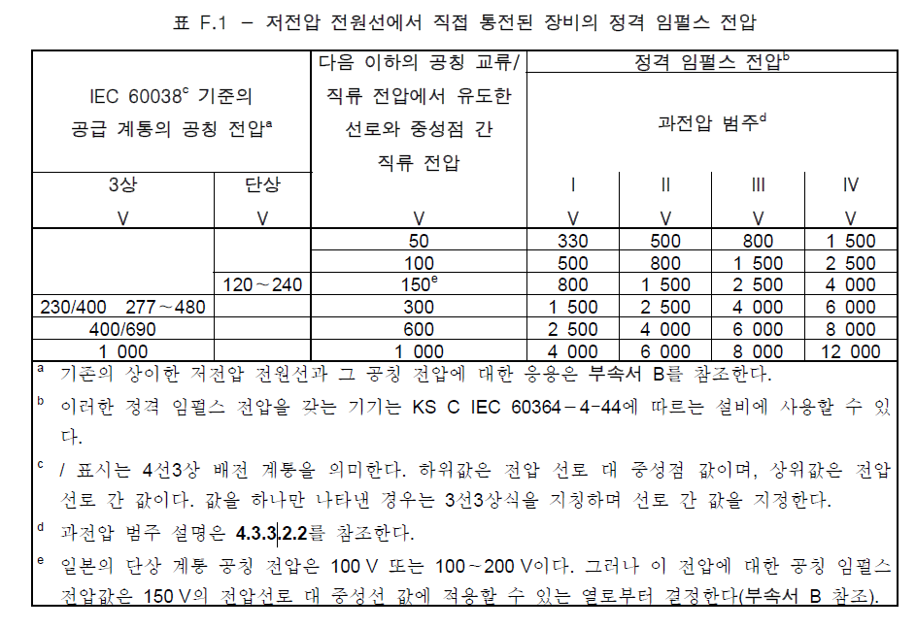

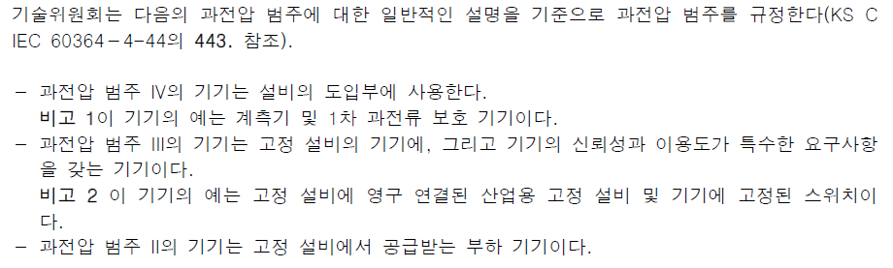

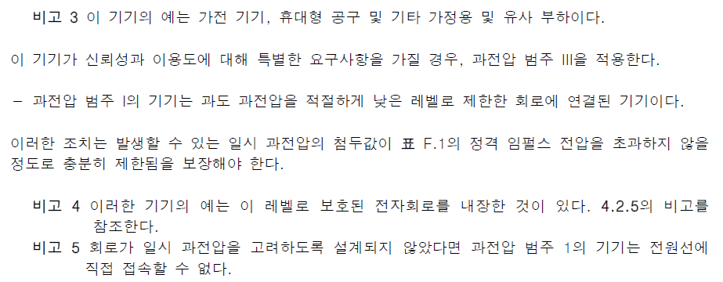

표. KC 60664-1의 일반적인 임펄스 전압 기준

##### 부품 내전압 고려 허용치 설정

* **커넥터 및 케이블, IPM, 포토커플러 사양 검토 시 : 2500V 이상 확인필요**

#### 공간거리 및 연면거리

##### 공간거리 및 연면거리 최소 요구사양

* 제어기 내부의 전기장은 이상적이지 않은 환경이므로, 비균일 전계인 경우 A로 분류한다.
* 먼지 및 습기로 인한 예기치 못한 오염을 고려하여 오염도 3으로 분류한다.
* 공간거리 : **최소 1.5mm 이상**
* 연면거리 : **고전압 라인에 공간거리 이상을 확보할 방안 추가**

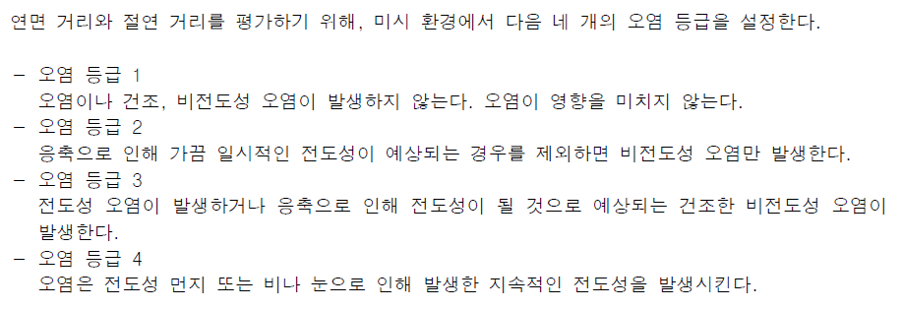

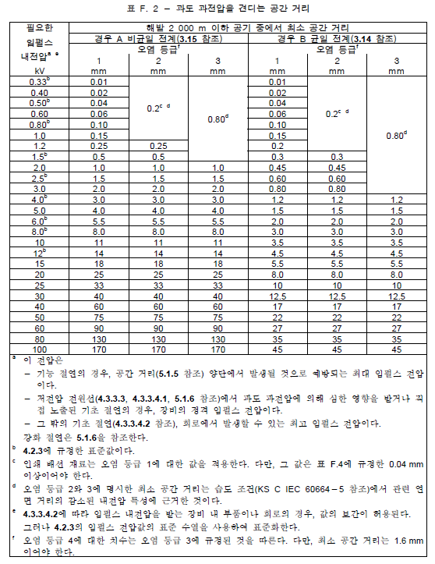

표. KC 60664-1의 과도전압을 견디는 공간거리 기준

##### 전력변환부의 도체 간 공간거리 최소 요구사양

* AMP보드의 전력변환부에 해당하는 대상은 아래와 같으며 IPC-9592B 표준에 근거한 과도전압 대비 최소간격을 사양으로 설정해야 한다.
* PN 커넥터
* 모터 커넥터
* IPM Power PIN
* 과도전압 2500V 기준, 하기 표를 통해 최소간격을 계산하였을 때, **최소 13.1mm이상 공간거리를 확보**해야 함을 알 수 있다.

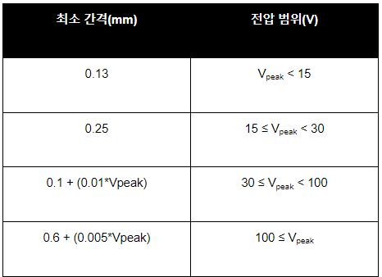

표. IPC-9592B의 전력변환장치에 대한 공간거리 최소기준

##### 부품 간 공간거리 및 연면거리 고려 허용치 설정

* 커넥터 : **최소 13.1mm 이상**
* IPM : **스펙시트에서 제시하는 공간거리 스펙 이상**
* 포토커플러 : 전기적 절연 pin간 **최소 1.5mm 이상 제품 확인**
* 고전압 핀간에는 연면거리 확보를 위해 PCB 아트웍 설계 시 cut-out 추가

#### PCB 아트웍 고려사항

* PCB 아트웍 시, IPC-2221 표준 및 상기 언급한 IPC-9592B 표준을 통해 사용전압레벨 311Vpeak 을 기준하여 최소 공간거리를 Clearace 사양으로 규정한다.
* PCB 패턴은 Solder masking을 통한 영구적인 폴리머코팅이 되어있다고 가정하였을 때, 최소 공간거리는 **최소 0.8mm로 설정한다.**
* PCB Via나 Throuth Hole간의 최소 공간거리는 IPC-9592B의 표준을 근거 및 311Vpeak 사용전압을 기준하여 **최소 2.2mm로 설정한다.**

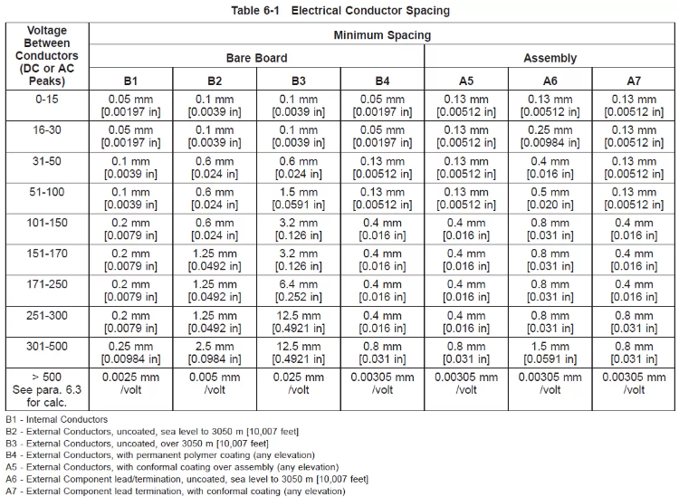

표. IPC-2221B의 도체 간격 공간거리 최소기준

#### PCB 제작물 사양

* FR4 재료로 만든 1.6T 두께의 표준적인 PCB는 일반적으로 최소 1.5Kv의 층간 내전압을 견딜 수 있다고 알려져 있다.
* PCB 보드 두께를 증가시켜 층간 거리를 키워 층간 절연성을 향상시키는 방법이 있다.
* PCB 제작물 사양은 다음과 같이 확정한다.
* **재료 : FR4, 두께 : 2T, 층수 : 최대 4-Layer, 코팅 : 유광**

#### 외함접지와 고전압라인 용량성 커플링 절연

* 외함 접지와 고전압 DC링크 전력라인을 용량성 커패시터(Y커패시터)로 커플링을 하여 아래의 상황에 대비한다.
* 인버터로부터 발생하는 고조파 전류원 노이즈로 인한 시스템 영향 간섭을 줄임
* 고전압 스파이크성 서지로 인한 시스템 손상 가능성 줄임
* 설계사양 : DC링크 PN 각 라인과 FG로 연결할 보드의 고정Hole에 **1kV 이상 내압 및 수 uF 용량의** **Film Capacitor을 연결**

### IPM 구동부 (HF302)

#### 고려사항 요약

* 고전압 파워부의 IPM 구동과 관련된 설계사양을 정의한다.
* 설계 고려사항으로는 다음과 같다.
* PWM 전달사양 (dead-time, time-delay)
* 스위칭 전기적 사양
* 부트스트랩 커패시터
* Sense 저항 또는 Shunt 저항
* IPM 제어용 전원부

#### PWM 전달 사양

##### Dead-time

* IPM마다 dead-time의 최소기준이 스펙시트에 명시되어 있다. (최소 3us 이내로 명시되어 있음)

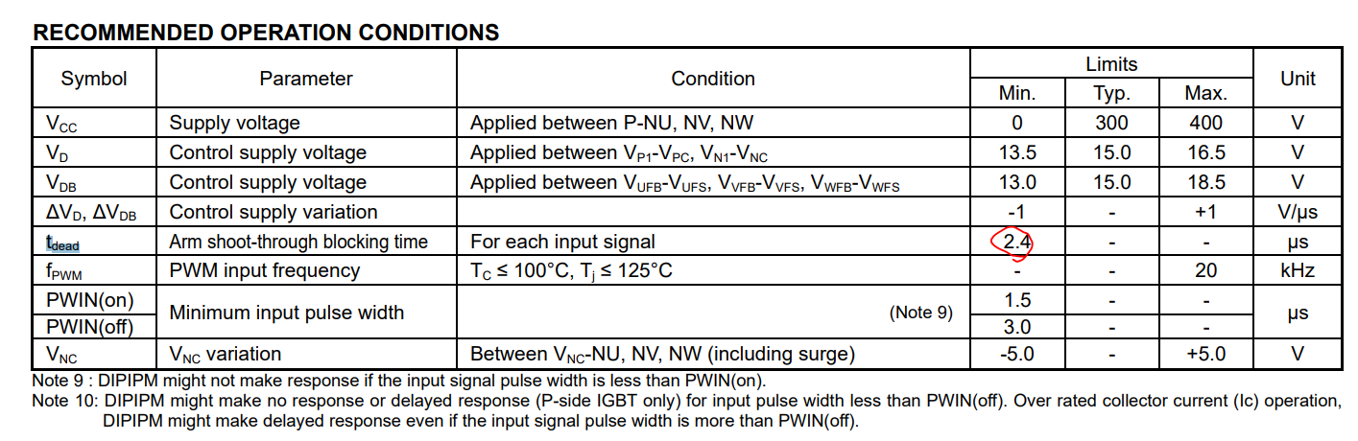

표. PSS75SA2F6 IPM 구동을 위한 최소 minimum dead-time

* BD642 (서보제어 & 안전 보드)의 PWM 출력의 dead-time 사양은 4us로 결정됨
* 해당 PWM신호를 AMP보드에서 인가받아 IPM 게이트까지 전달받았을 **때 dead-time 사양은 timing delay를 고려하여 4~6us 이내로 정한다.**
* Deadtime을 재는 기준은 IPM의 스펙시트마다 차이가 있지만 공통적으로 아래와 같기 때문에 **상승지점의 2.1V시점 – 하강지점의 1.3V시점 사이의 시간을 측정한다.**



표. PSS35S92 IPM의 PWM 신호인식 임계전압 사양



표. PSS50SA2F6 IPM의 PWM 신호인식 임계전압 사양



표. PSS75SA2F6 IPM의 PWM 신호인식 임계전압 사양



표. PSS100NE1CT IPM의 PWM 신호인식 임계전압 사양

##### Timing Skew

* 고속포토커플러를 사용하여 IPM의 Gate에 PWM 신호를 인가하여 Timing delay를 최대한 감소시켜 제어성능에 문제를 일으키지 말아야 한다.
* 고속포토커플러 입력단 대비 출력의 **timing delay가 200ns가 넘지 않도록 사양을 설정**한다.
* IPM Gate dead-time 마진이 약 2us 이므로, 해당 마진의 10%로 사양 설정

#### 스위칭 전기적 사양

##### PWM Input

* 전압 레벨 : High : **15V ± 5% // Low : 0V**
* IPM 타입 대비 포토커플러 출력회로 : 제어보드에서 High 신호를 인가할 때 **High Active**가 되도록 설계
* 상승 / 하강 라이징/폴링 타임 : 포토커플러 스펙시트 사양 (보통 **20us**)

##### Collector – Emitter 스위칭 타임

* **IPM 별 스펙시트 상의 타이밍 사양**
* 하기 그림 참고

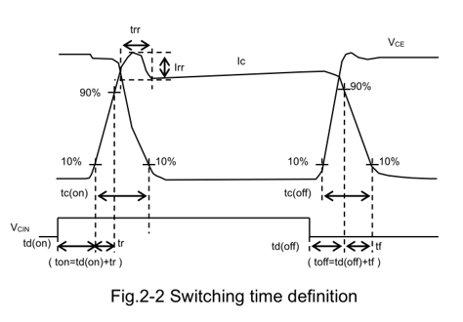

그림 . IPM 내부 IGBT의 Gate 신호 대비 Collector-Emitter Switching 타임 고려항목

#### 부트스트랩 커패시터

* 부트스트랩 커패시터 용량선정은 정확한 계산에 의거하여 선정하기 어려운 면이 있다.
* 어플리케이션 가이드에서 사용한 커패시터 용량을 선제적으로 사용하고 하기와 같은 시험을 통해 용량을 실험적으로 선정한다.
* Motor ON 시작 시 부트스트랩 Charging
* 100%속도의 풀부하를 가진 로봇의 가혹한 모션에서 부트스트랩 커패시터의 전압변동률

#### Sense 저항 또는 Shunt 저항

* Sense 저항 또는 Shunt 저항은 센싱된 전압값을 과전류 폴트신호를 생성하기 위한 입력신호로 사용한다.
* 용량이 큰 IPM은 Sense 저항을 사용하여, 용량이 작은 IPM은 Shunt 저항을 사용한다.
* **선정된 IPM이 정격전류에 도달하였을 때, 폴트신호를 생성할 수 있는 적절한 저항을 선정한다.**

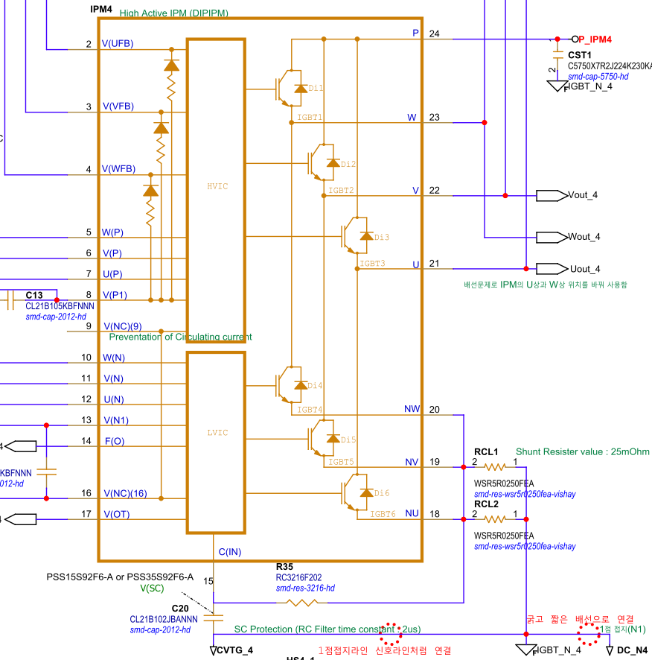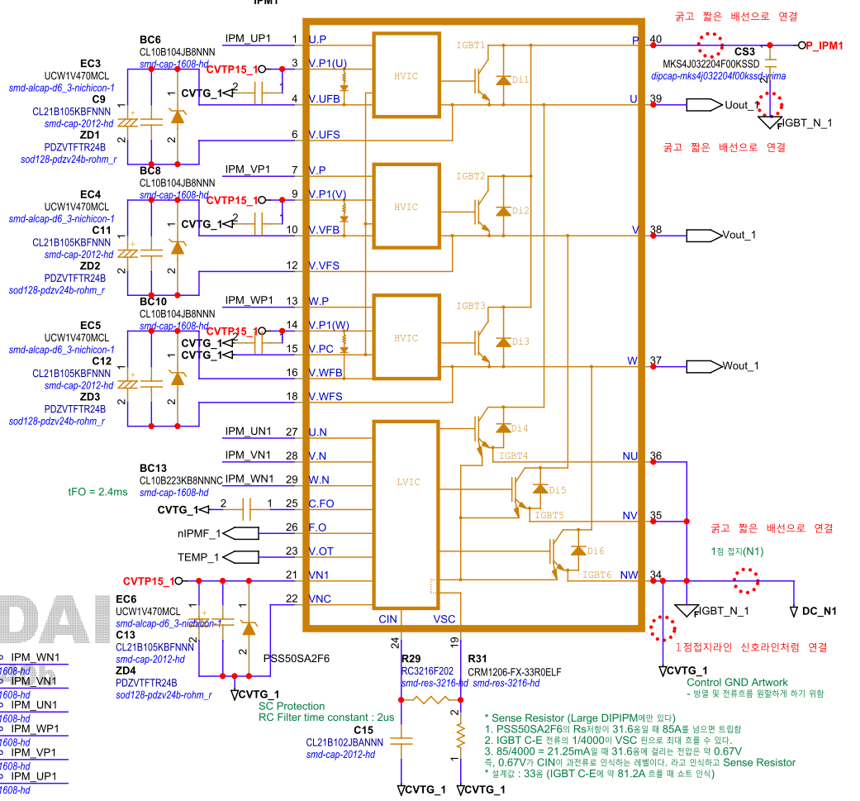

그림. 좌측 : Shunt 저항 회로도 예시 // 우측 : Sense 저항 회로도 예시

#### IPM 제어용 전원부

##### 제어전원 사용 포인트

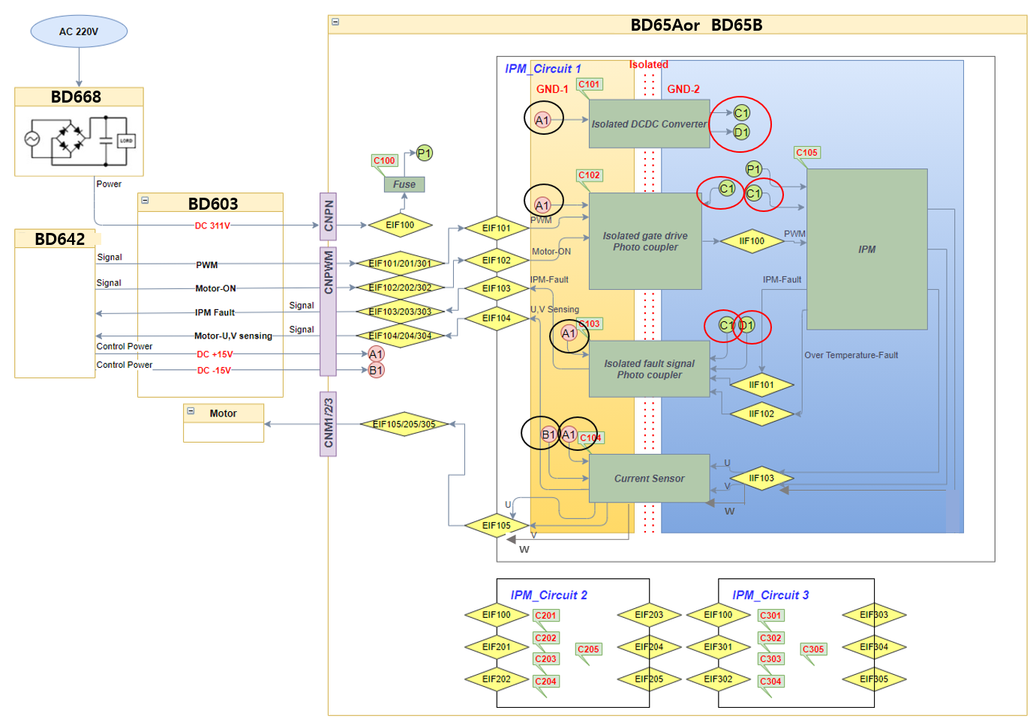

The requirements :

- A1 : 15V (from BD642)

- B1 : -15V (from BD642)

- C1 : 15V (from Isolated DC/DC Converter)

- D1 : 5V (from Isolated DC/DC Converter)

##### 제어전원 입출력 전기적 사양

* IPM이 전류를 증폭하는 구동조건에 따라 소비전류가 급변할 수 있다.
* 제어전원 전압 출력이 일정하게 유지가 되면서 전류를 안정적으로 공급할 수 있는 DC/DC 컨버터를 선정해야 한다.
* 제어전압이 약 12V 이하로 drop할 때 IPM은 폴트신호를 출력하게 되므로, **load regulation 사양이 5프로 이내의 DC/DC 컨버터를 선정한다.**
* 출력전류 순간 최대 소모량은 약 40mA 이내로 예상할 수 있다. **최대소모전류의 1.5배 마진률을 곱한 60mA 이상의 출력이 가능한 DC/DC 컨버터를 선정한다.**

|  |  |  |  |  |  |  |
| --- | --- | --- | --- | --- | --- | --- |
| Test Point | Contents |  | Voltage | | Current | |
| 판정기준 | Min | Max | Min. | Max. |
| + 15V | AMP 구동 제어전원 절연 DC/DC 컨버터 | AMP 제어전원 소비전류 합산 | 14.5V | 15.5V | - | 32mA |
| IPM gate  신호전달 회로 | 회로 소비전류 계산 | - | 회로설계치 |
| 폴트 신호전달 회로 | 회로 소비전류 계산 | - | 1.5mA |
| 전류센서 | 데이터시트 | - | 40mA |
| -15V | 전류센서 | 데이터시트 | -15.5V | -14.5V | - | 40mA |

표. IPM 제어전원 입력전압별 소비전류 사양

|  |  |  |  |  |  |  |
| --- | --- | --- | --- | --- | --- | --- |
| Test Point | Contents |  | Voltage | | Current | |
| 판정기준 | Min | Max | Min. | Max. |
| + 15V | IPM | 데이터시트 | 14.5V | 15.5V | - | Gate driver : 5.5mA  부트스트랩 : 16.5mA |
| IPM gate  신호전달 회로 | 회로 소비전류 계산 | - | 회로 설계치 |
| 폴트 신호전달 회로 | 회로 소비전류 계산 | - | 10mA |
| +5V | 폴트 신호전달 회로 | 회로 소비전류 계산 | 4.8V | 5.2V | - | 회로 설계치 |

표. IPM 제어전원 출력전압별 소비전류 사양

##### 제어전원 Fault 방어 대책

* 제어전원이 예기치 못한 폴트상태에 진입하였을 때 보호회로가 갖춰져야 한다.
* 제어전원 출력전류가 정격 최대전류 이상의 전류를 흘리게 되면 출력을 멈추도록 하는 장치를 갖춘다.
* **쇼트 시 protection 회로 내장된 DC/DC컨버터 부품 사용**
* **DC/DC 컨버터 출력단에 퓨즈 장착**
* IPM은 하기 표의 제어전원 출력전압레벨에 따라 제어불능의 상태에 있을 수 있다.
* 제어전압 감시회로를 구성하여 **13V 이하 및 18.5V 이상일 때 폴트신호를 생성**하도록 한다.

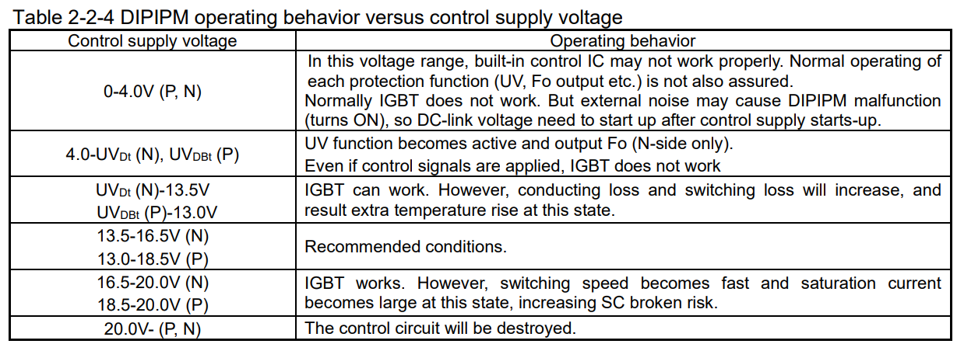

표. 제어전원 전압레벨에 따른 IPM 상태구분

### IPM Fault 신호 출력부 (HF304)

#### 고려사항 요약

* IPM 내부에는 자기 상태를 감시하는 폴트출력회로가 내장되어 있다.
* IPM의 폴트 신호출력 신호가 신뢰성이 있다는 가정 하에, AMP보드는 해당 신호의 전달회로 설계사양을 정의한다.
* 설계 고려사항으로는 다음과 같다.
* 폴트 출력회로 구성
* 과온도
* 암쇼트
* 제어전원 모니터링
* 부트스트랩 상단 충전전압 모니터링

<https://www.mitsubishielectric.com/semiconductors/files/manuals/ipm_g1_note_e2.pdf>

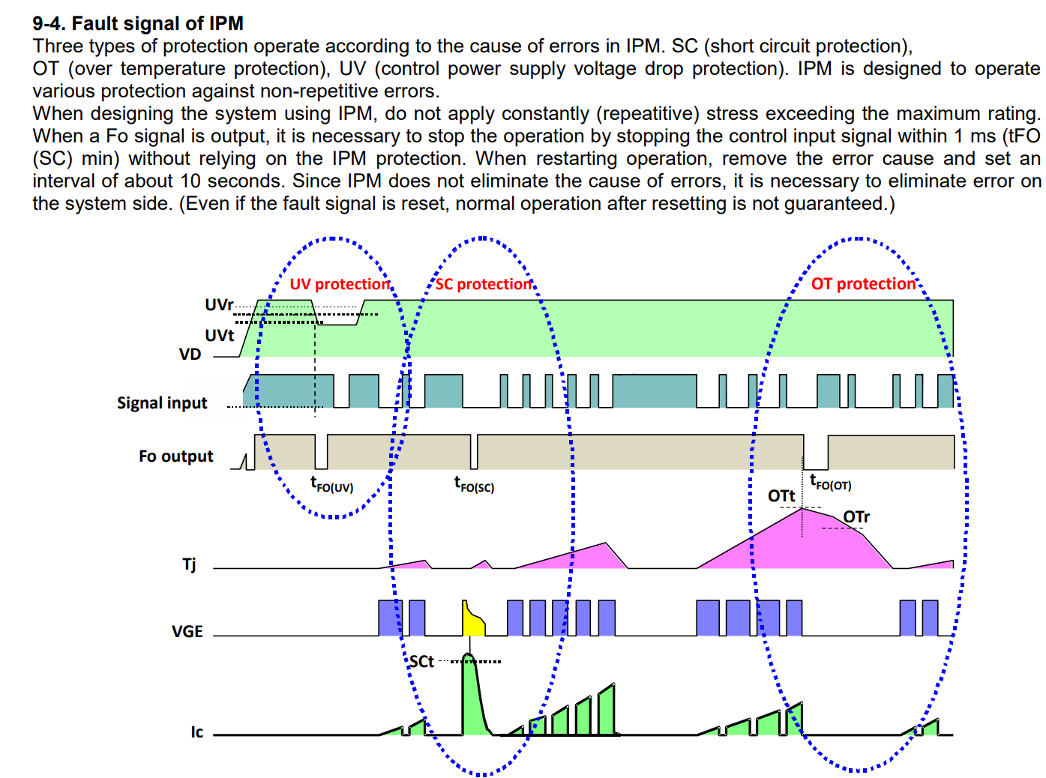

그림. 제어전원, 암쇼트, 과온도에 따른 IPM폴트 Timing도

#### 폴트 출력회로 구성

- Large DIPIPM - Super-mini DIPIPM

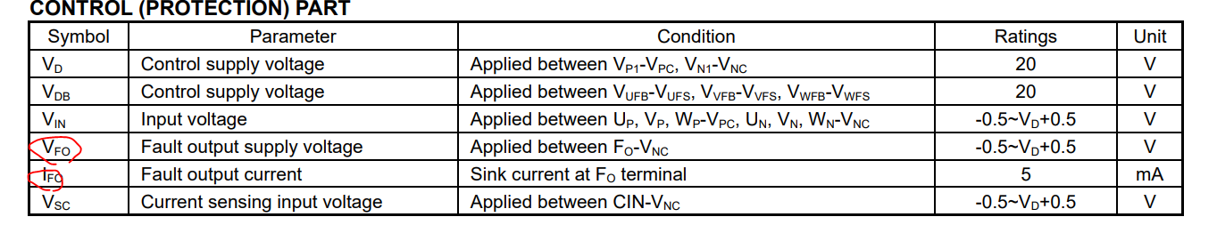



#### 과온도

IPM 실제 동작전압

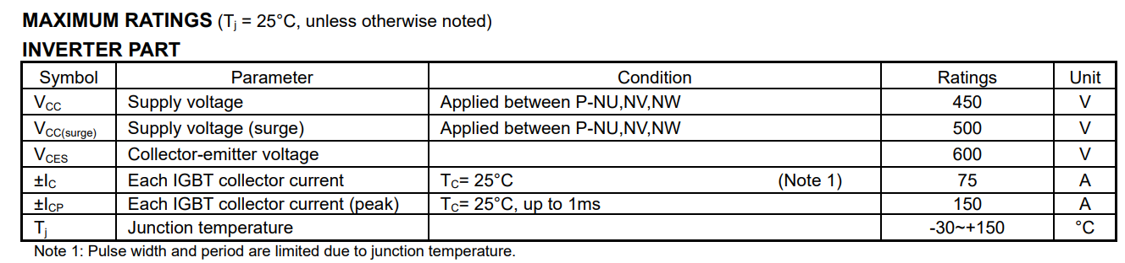

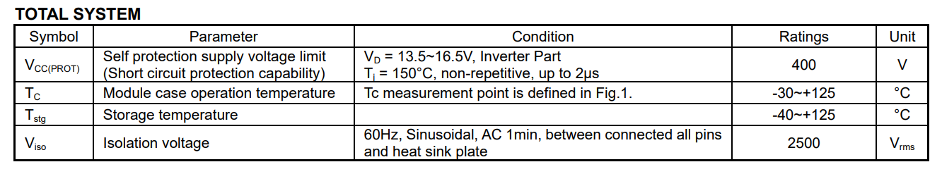

자기 온도 상태에 대한 히스테리시스 그래프 및 과온에러 값

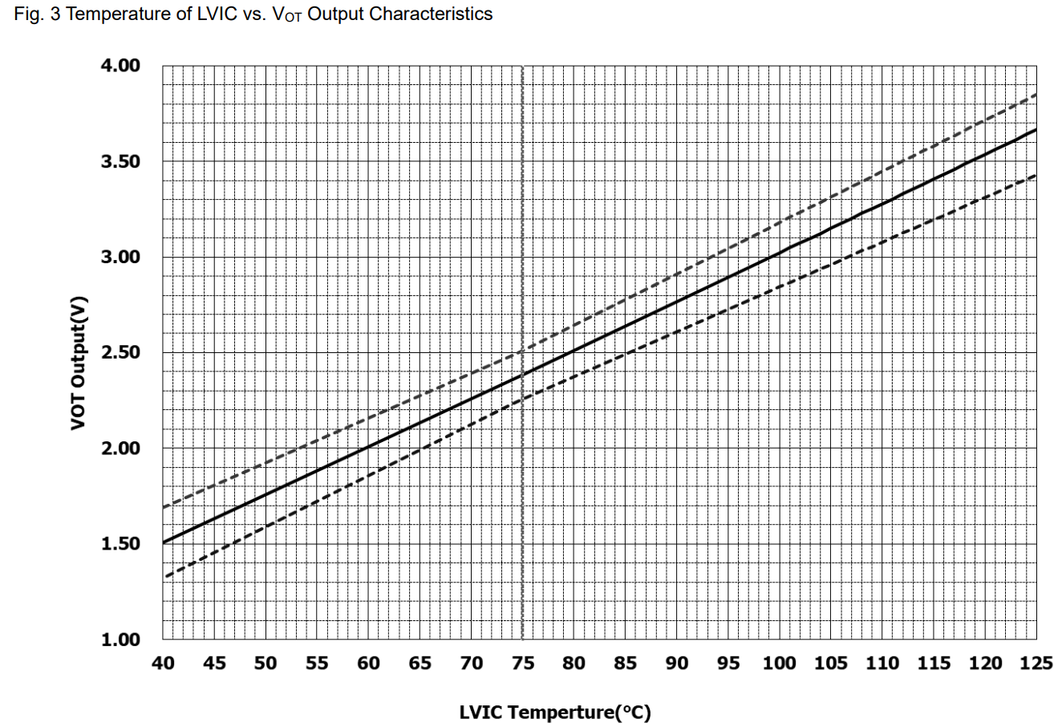





#### 암쇼트

The requirements

암 쇼트 발생 시 IPM 버티는 시간 -> 최소 1.6ms까지는 버틴다는 의미



#### 제어전원 모니터링

The requirements

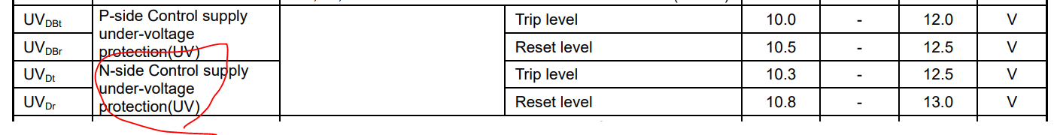

#### 부트스트랩 상단 충전전압 모니터링

The requirements

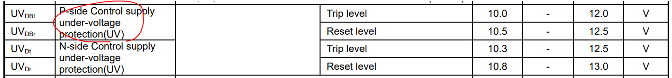

### 전류 센싱부 (HF304)

#### 고려사항 요약

* 자사 제어기의 전류제어를 위한 모터 U,V상 전류피드백 및 위치판별 안전이중화를 위한 모터 W상 전류피드백을 위한 설계사양을 정의한다.
* 설계 고려사항으로는 다음과 같다.
* 전류센서 타입 선정
* IPM 용량별 전류센서 매칭
* W상 전류센서

#### 전류센서 타입 선정

The requirements

다양한 전류센서가 있다. 이 중에 우리는 홀센서타입 전류센서를 사용한다. 왜?



#### IPM 용량별 전류센서 매칭

Hi5a/Hi6 서보앰프 사양과 전류파라미터 관계

<http://confluence.hhirob.com:8090/pages/viewpage.action?pageId=13992609>

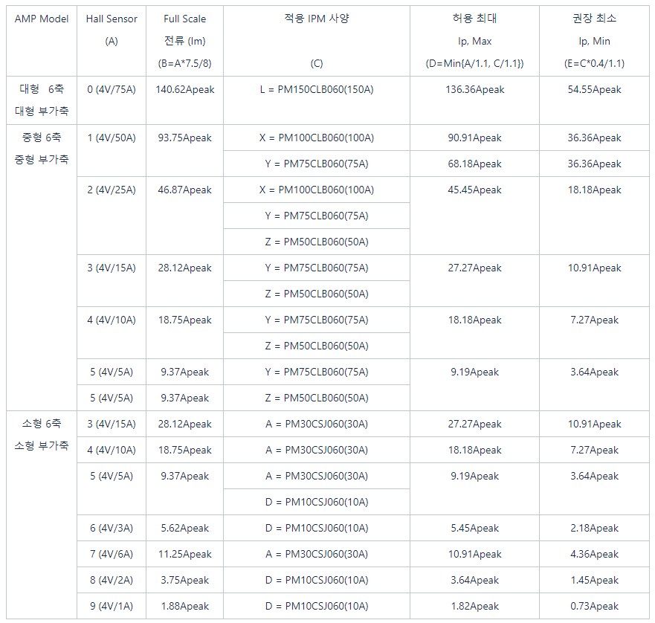

#### W상 전류센서

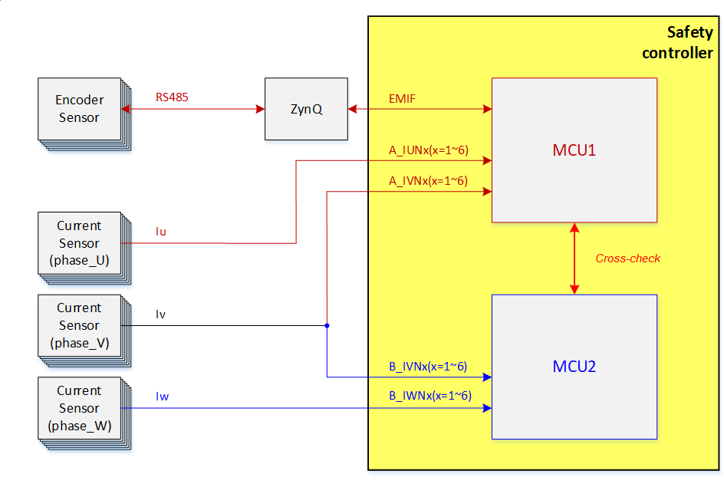

우리의 Safety Concept에서 W상 전류센서의 활용 요구조건은 전류피드백에 사용하는 U/V 전류센서와 동등한 사양으로 활용한다.

### 방열 (HF305)

#### 고려사항 요약

* IPM의 스위칭손실로 인해 발생하는 발열
* IPM 열저항 및 방열구조
* 열전달 매개체 (써멀구리스 및 써멀패드)
* 방열판 치부

#### IPM 열저항 및 방열구조

반도체소자의 열저항값은 반드시 방열판 설계에서 고려되어야 한다.



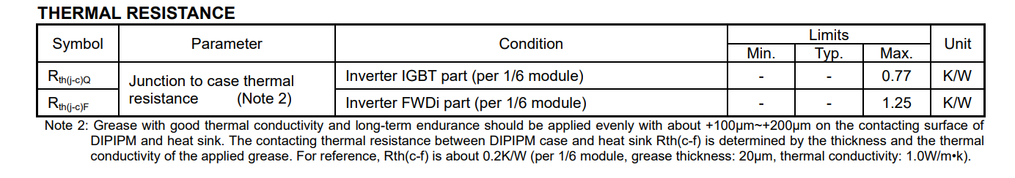

+ IPM 제조사에서 제공하는 방열판 구조 가이드라인

#### 열전달 매개체 (써멀구리스, 써멀패드 등)

#### 방열판 치부

- PSS75SA2F6

<https://www.mitsubishielectric.com/semiconductors/files/manuals/600v_large_dipipm_ver6_e.pdf>

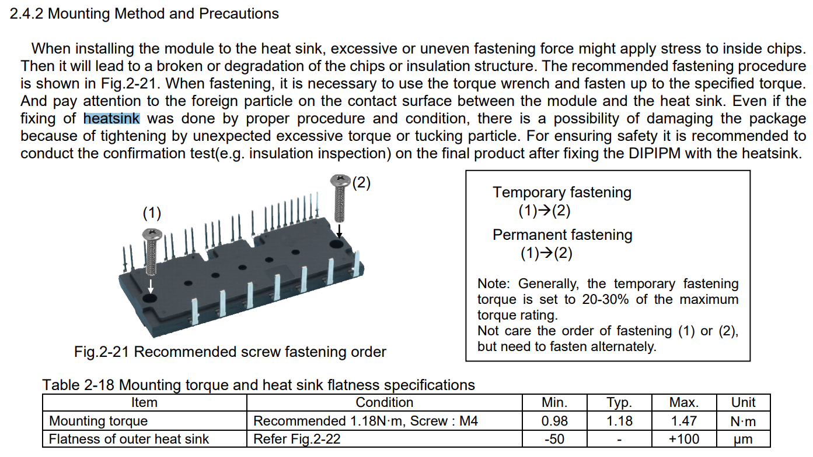

- Super-Mini DIP

<https://www.mitsubishielectric.com/semiconductors/files/manuals/super_mini_dipipm_ver6_e.pdf>

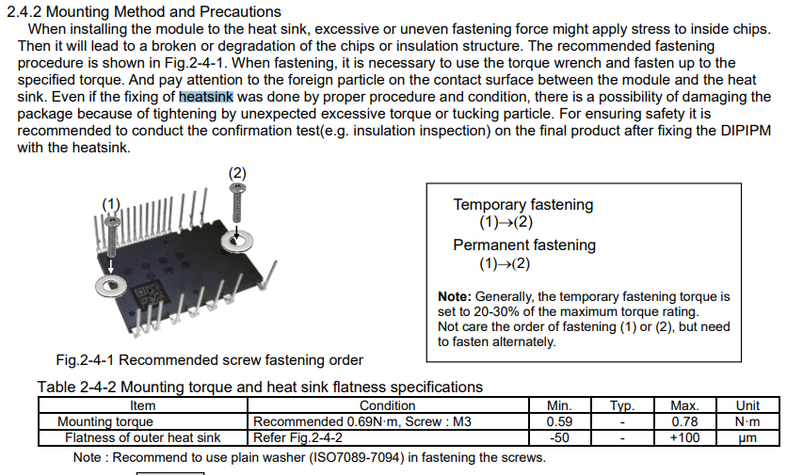

## Safety Communication Board

### Safety-Communication Function (: HF401)

#### Design Requirements

The requirements of safety-communication are as follow.

- Hardware test are performed according to specifications of PROFINET hardware (e.g. IEEE 802.3 or IEEE 802.11 or IEEE 802.15)

- Safety communication and non-safety communication can be performed as below



#### Functional Description

The following figure illustrates safety-communication function.

- Safety communication can be performed through each ethernet port(each channel)

- Communication error can be checked by Safe space 2.0 refer to SDS

- MCU1 get both safety data and non-safety data. non-safety data will be transfer to MCU2.

### Power supply function (: HF402)

#### Design Requirements and functional description

The requirements of power supply function are as follows.

- The power input stage shall include protective measures against over-current.

* + - The power source used for control is DC24V and is supplied from safe space 2.0.



#### Required power

Max power consumption of Safety Communication Board is shown as below

* + - MCU1 parts

| **Circuits** | **Devices** | **3.3[V]** | **1.8[V]** | **1.5[V]** | **1.2[V]** |
| --- | --- | --- | --- | --- | --- |
| MCU | ERTEC200P-Step2 | 108mA | 47mA | 168mA | 422mA |
| MCU peripheral circuit | OSC | 1.8mA |  |  |  |
| LED | 3.3mA x 8 = 26.4mA |  |  |  |
| RS485 | THVD1420DRLR | 75mA |  |  |  |
| RS232 | MAX3232EIPWRQ1 | 1mA |  |  |  |
| SDRAM | MT48H16M32LFB5 |  | 90mA |  |  |
| Reset IC | TLC7733QD | 2mA |  |  |  |
| Memory | AT45DB321E | 17mA |  |  |  |
| Total required Current | | About 231.2mA | About 137mA | About 168mA | About 506.4mA |
| Total required Power | | 762.96mW | 246.6mW | 169.5mA | 506.4mA |
| Required power in DC24V | | DC24V / 70.22mA = 1685.46mW | | | |

* + - MCU2 parts

| **Circuits** | **Devices** | **3.3[V]** | **1.2[V]** |
| --- | --- | --- | --- |
| MCU | TMS320F28388D | 76.0mA | 478.0mA |
| MCU peripheral circuit | OSC | 33.0mA |  |
| LED | 3.3mA x 9 = 29.7mA |  |
| EtherCAT PHY | KSZ8081MNXIA | 28.0mA x 2 = 56.0mA |  |
| Memory | AT24C16C | 5.0mA |  |
| Total required Current | | About 199.7mA | 478.0mA |
| Total required Power | | 659mW | 1147.2mW |
| Required power in DC24V | | DC24V / 75.25mA / 1806.21mW | |

# Electronic/Electric components

## Parts list

| **No.** | **Components** | **Model name** | **Specifications** | **Certification** |
| --- | --- | --- | --- | --- |
| HC001 | NFB | HGM30 3P 15A | Rated insulation voltage : 1,000V  rated operational voltage : 690V  impulse withstand voltage : 8kV  Protective function : overload, short-circuit and instantaneous protection  Rated current : 16 A, 3 pole | IEC 60947-1  IEC 60947-2  KS C 8321  KS C 4613 |
| HC002 | NFT(Noise Filter) | P3B5030-DH | Rated voltage : AC 500V, 3phase  Rated current : 60 A | IEC60939-2(2005) |
| HC003 | Circuit Protector | BW32AAG-39015-CE | Rated insulation voltage : AC 500 V  Rated current : 15A  Ampere frame : 32A | IEC 60947-2  EN 60947-2  GB 14048.2(CCC)  JIS C 8201-2-1  JIS C 8201-2-2 |
| HC004 | Magnetic Contact | LC1D256BL DC24V | Rated operational voltage : under 690V AC 25-400Hz for power  Rated operational current : 40A(under 60°C) AC-1  rated impulse withstand voltage : 6kV conforming to IEC60947 | EN 60947-4-1  EN 60947-5-1  IEC 60947-4-1  IEC 60947-5-1  UL 508  CSA C22.2 No 14  B10d = 20000000 cycles contactor with mechanical load conforming to EN/ISO 13849-1  B10d = 1369863 cycles contactor with nominal load conforming to EN/ISO 13849-1 |
| HC005 | SMPS | DRF-24V240W1GBA | Rated output voltage : DC 24V  Rated input voltage : AC 90-264V  Rated output current : 10A(240W) | EN 62368-1:2014+A11:2017  EN 61010-1: 2010  EN IEC 63000:2018  EN 50563: 2011+A1: 2013 |
| HC006 | Buffer | 2786250000 | Rated input voltage : DC 22.5 – 30V  Rated input current : 0…41A  Rated output voltage : DC 22.2V  Rated output current : 40A | EN 61000-4-2, -3, -4, -5, -6 class B  EN60204  SELV acc. to IEC 60950-1, PELV according to EN 60204-1  ETIM 8.0  ECLASS 12.0 |
| HC007 | Fan | AFB1224SHE-R00 | Rated voltage : DC 24V  Power : 12 W  RPM : 3700 PRM  Current rating : 0.5A | - |
| HC008 | Regenerative resistor | IRF500C 15ohm | Rated operating temperature : -55°C~200°C  Rated Power on heat sink : 150W | - |

# Revision History

| Revision History | Hardware Design Specification |
| --- | --- |

| **Rev** | **Date** | **Description** | | **Updated**  **by** | **Reviewed by** | **Approved by** |
| --- | --- | --- | --- | --- | --- | --- |
| **Page** | **Summary** |
| 1.0 | 2022.12.14 | All | Created |  |  |  |
|  |  |  |  |  |  |  |
|  |  |  |  |  |  |  |
|  |  |  |  |  |  |  |
|  |  |  |  |  |  |  |
|  |  |  |  |  |  |  |
|  |  |  |  |  |  |  |
|  |  |  |  |  |  |  |
|  |  |  |  |  |  |  |
|  |  |  |  |  |  |  |
|  |  |  |  |  |  |  |
|  |  |  |  |  |  |  |
|  |  |  |  |  |  |  |
|  |  |  |  |  |  |  |
|  |  |  |  |  |  |  |
|  |  |  |  |  |  |  |
|  |  |  |  |  |  |  |
|  |  |  |  |  |  |  |
|  |  |  |  |  |  |  |
|  |  |  |  |  |  |  |